Manufacturing Readiness Level (MRL) Deskbook
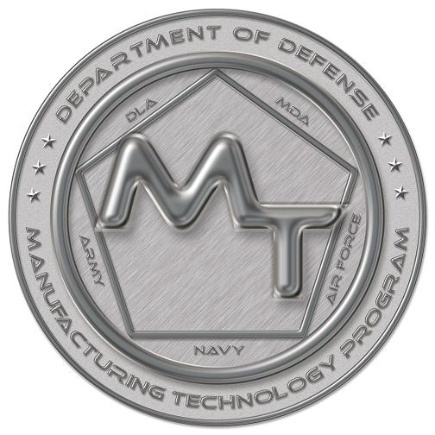

Version

2018

Prepared by the
OSD Manufacturing Technology Program
In collaboration with
The Joint Service/Industry MRL Working Group

This document is not a DOD requirement and is being offered as a Best Practice
V2.2.2: This version has changes made to the Criteria matrix in the appendix to agree with V 11.4 dated 15 December 2014.
V2.3: This version has changes made to add changes coming from the 2014 Workshop to address the new DODI 5000.02 and User comments.
V2.4: This version has corrections in the Matrix to version 11.5.
V2.5: This version has changes in Appendix A – to update the Matrix to version 11.6 including additional criteria under H.1 Tooling and adds Chapter 8, “Effectively Adapting and Utilizing MRL Criteria”.
2016: This version has changes in Appendix A – to update the Matrix to version 11.6 including additional criteria under H.1 Tooling and adds Chapter 8, “Effectively Adapting and Utilizing MRL Criteria”.
2017: This version adds section 6.7, MRLs in SAE AS6500.
2018: Adjusted wording in MRL definitions to match 2018 criteria and metrics, including ESH additions. Updates for clarity and changes in statutes, policies, and guidance (Chapter 3 and elsewhere). 2018 Matrix update to Appendix A.

Table of Contents
_
Executive Summary 1
1. Introduction 2
1.1 Manufacturing Risks Recognized in Policy 2
1.2 Guidance Issued in Support of Policy 4
1.3 Overarching Best Practices for Complying with Policy and Guidance 7
1.4 Purpose and Organization of this Document 8
2. Manufacturing Readiness Levels 10
2.1 Introduction to Manufacturing Readiness Levels 10
2.2 MRLs and Their Relationship to TRLs 10
2.3 Manufacturing Readiness Levels Defined 11
2.4 Definition of Terms 14
2.5 MRL Threads and Sub-Threads 16
3. MRLs and the Acquisition Management System 19
3.1 Introduction 19
3.2 Manufacturing Readiness during Pre-Systems Acquisition 21
3.3 Manufacturing Readiness During Systems Acquisition 25
4. Conducting Assessments of Manufacturing Readiness 29
4.1 Introduction 29
4.2 Determine Initial Assessment Scope 30
4.3 Determine Assessment Taxonomy and Schedule 31
4.4 Form and Orient Assessment Team 33
4.5 Orient Contractors Being Assessed 34
4.6 Request Contractors Perform Self-Assessment 35
4.7 Set Agenda for Site Visits 36
4.8 Conduct the Assessment of Manufacturing Readiness 36
4.9 Prepare the Assessment Report 39
5. Manufacturing Maturation Plans and Risk Management 41
5.1 Introduction 41
5.2 Development of a Manufacturing Maturation Plan 42
5.3 Risk Management Best Practices 42
6. Applying MRLs in Contract Language 45
6.1 Introduction 45
6.2 Strategies for Competitive RFP Language 45
6.3 Manufacturing Readiness RFP Language for Source Selection 46
6.4 SOO Language For All RFPs 47
6.5 SOW Language For Contracts 48
6.6 Other Deliverables 49
7. A Tool for Performing Assessments of Manufacturing Readiness 50
7.1 The MRL Users Guide 50
8. Effectively Adapting and Utilizing MRL Criteria 52
8.1 Introduction 52
8.2 MRL Criteria in the S&T Environment 53
8.3 MRL Criteria for Sustainment/Maintenance, Repair & Overhaul (MRO) and Depot Activities 56
8.4 MRLs for Single or Limited System Acquisition 58
8.5 MRL Criteria for Industry 61
APPENDIX A – Detailed MRL Criteria A-1
Table A-1. Manufacturing Readiness Levels for the Technology and Industrial Base Thread A-1
Table A-2. Manufacturing Readiness Levels for the Design Thread A-2
Table A-3. Manufacturing Readiness Levels for the Cost and Funding Thread A-3
Table A-4. Manufacturing Readiness Levels for the Materials Thread A-4
Table A-5. Manufacturing Readiness Levels for the Process Capability and Control Thread A-5
Table A-6 Manufacturing Readiness Levels for the Quality Management Thread A-6
Table A-7. Manufacturing Readiness Levels for the Manufacturing Personnel and Facilities Threads A-7
Table A-8. Manufacturing Readiness Levels for the Manufacturing Management Thread A-8
APPENDIX B – Acronyms B-1
List of Figures
Figure 3-1. Relationship of MRLs to Decision Points, Milestones, Technical Reviews, and TRLs 20
Figure 4-1. Sample Process Flow for Conducting 29
Figure 4-2. Example of Added Detail Derived from Site Visits 38
Figure 8-1 – Relationship of MRLs to SMLs 56
Figure 8-2 – Example of Unplanned Depot Activation Circumstance 57
Figure 8-3 – Single or Limited System Acquisitions – except Ships 59
Figure 8-4 – Single or Limited System Acquisitions – Ships 61
Figure 8-5 – Gated Product Development 61

Executive Summary
Manufacturing status and risk evaluations have been performed as part of defense acquisition programs for years in a variety of forms. These evaluations, while often highly structured and well managed, did not use a uniform metric to measure and communicate manufacturing risk and readiness. They were not conducted on technology development efforts or in early acquisition phases. Furthermore, the frequency of these types of evaluations has declined since the 1990s. Paralleling this decline, manufacturing-related impacts on cost and schedule have grown.
New policy was established to address this problem in Department of Defense Instruction 5000.02, Operation of the Defense Acquisition System. It establishes target maturity criteria for measuring risks associated with manufacturing processes at Milestones A, B, and C and Full Rate Production. However, quantitative assessments are necessary to determine whether these criteria have been met.
Assessments of manufacturing readiness utilizing the Manufacturing Readiness Level (MRL) criteria have been designed to manage manufacturing risk in acquisition while increasing the ability of the technology development projects to transition new technology to weapon system applications. MRL criteria create a measurement scale and vocabulary for assessing and discussing manufacturing maturity and risk. Using the MRL criteria, an assessment of manufacturing readiness is a structured evaluation of a technology, component, manufacturing process, weapon system, or subsystem. It is performed to:
- Define current level of manufacturing maturity
- Identify maturity shortfalls and associated costs and risks
- Provide the basis for manufacturing maturation and risk management
This document provides best practices for conducting assessments of manufacturing readiness. It is designed for acquisition program managers and managers of those technology development projects and pre-systems acquisition technology demonstration projects intending to transition directly to the acquisition community as well as the people who are involved in conducting the assessments.

Introduction

1.1 Manufacturing Risks Recognized in Policy
Manufacturing status and risk evaluations have been performed as part of defense acquisition programs for years in a variety of forms (e.g. Production Readiness Reviews, Manufacturing Management/Production Capability Reviews, etc.)⁽⁾. These reviews, while often highly structured and well managed, did not use a uniform metric to measure and communicate manufacturing risk and readiness. They were not conducted on technology development efforts or in early acquisition phases. Furthermore, the frequency of these types of reviews has declined sharply since the 1990s.
Paralleling this decline, manufacturing-related impacts on cost, schedule, and performance have grown. Studies by the Government Accountability Office (GAO) cite a lack of manufacturing knowledge at key decision points as a leading cause of acquisition program cost growth and schedule slippages in major DoD acquisition programs⁽⁾. Consequently, policy has been developed to strengthen the way in which manufacturing issues and risks are considered in the defense acquisition system.
There is a long standing policy on manufacturing-related content of acquisition strategies. Defense Federal Acquisition Regulation Supplement (DFARS) Section 207.105b (Contents of Written Acquisition Plans)⁽⁾ mandates specific national technology and industrial base considerations are included in acquisition strategies for major defense acquisition programs as follows:
- An analysis of the capabilities of the national technology and industrial base to develop, produce, maintain, and support such program, including consideration of factors related to foreign dependency
- Consideration of requirements for efficient manufacture during the design and production of the systems to be procured under the program
- The use of advanced manufacturing technology, processes, and systems during the research and development phase and the production phase of the program
- To the maximum extent practicable, the use of contract solicitations that encourage competing offerors to acquire, for use in the performance of the contract, modern technology, production equipment, and production systems (including hardware and software) that increase the productivity of the offerors and reduce the life-cycle costs
- Methods to encourage investment by U.S. domestic sources in advanced manufacturing technology production equipment and processes through:
  - Recognition of the contractor’s investment in advanced manufacturing technology production equipment, processes, and organization of work systems that build on workers’ skill and experience, and work force skill development in the development of the contract objective; and
  - Increased emphasis in source selection on the efficiency of production.
Both Congress and GAO have placed additional focus on manufacturing. Specifically, Congress has put the focus of managing manufacturing risk as a “Public Law”⁽⁾… “the Secretary of Defense shall issue comprehensive guidance on the management of manufacturing risk in major defense acquisition programs” and “identify critical technologies and manufacturing processes that need to matured by Milestone A and that have not been successfully demonstrated in a relevant environment by Milestone B”
The GAO⁽⁾ found that DOD faces problems in manufacturing weapon systems — systems cost far more and take much longer to build than estimated. Billions of dollars in cost growth occur as programs transition from development to production, and unit cost increases are common after production begins. Contributing factors to these problems include the following: Inattention to manufacturing during planning and design, poor supplier management, and a deficit in manufacturing knowledge among the acquisition workforce. Essentially, programs did not identify and resolve manufacturing risks early in development, but carried risks into production where they emerged as significant problems. The GAO has recommended DoD adopt the use of MRLs to help manage the manufacturing risk.
The current Department of Defense Instruction (DoDI) 5000.02 continues to reinforce the requirement to address manufacturing over the entire life cycle. Provided are some of the new requirements. It now requires the Program Manager (PM) to ensure manufacturing risk is addressed throughout the program’s lifecycle. Beginning in the Materiel Solution Analysis (MSA) Phase, policy requires manufacturing readiness and risk be assessed and documented in the Systems Engineering Plan (SEP) ⁽⁾
By the end of the Technology Maturation Risk Reduction (TMRR) Phase:
- Risk reduction prototypes will be included if they will materially reduce engineering and manufacturing development risk at an acceptable cost. Risk reduction prototypes can be at the system level or can focus on sub-systems, or components.⁽⁾
- Leaving this phase requires final demonstration that all sources of risk have been adequately mitigated to support a commitment to design for production.⁽⁾ This will be accomplished by assessing and demonstrating manufacturing processes to the extent needed to verify risk has been reduced to an acceptable level.
During the Engineering and Manufacturing Development (EMD) Phase, program managers will assess the maturity of critical manufacturing processes to ensure they are affordable and executable. Prior to a production decision, the PM will ensure manufacturing and producibility risks are acceptable, supplier qualifications are completed, and any applicable manufacturing processes are or will be under statistical process control.⁽⁾
The new DoDI states that the Low Rate Initial Production (LRIP) line provides an efficient ramp up to Full Rate Production (FRP).⁽⁾
In support of the requirements above, the Defense Acquisition Guide, Chapter 4⁽⁾, states that assessment of manufacturing risks is a best practice and refers to this guide to accomplish this requirement.

1.2 Guidance Issued in Support of Policy

1.2.1 Manufacturing Related Success Criteria Established for Acquisition Strategies
In support of both DFARS language and 5000.02, the Defense Acquisition Guidebook (DAG) Chapter 2 (Acquisition Program Baselines, and Acquisition Strategies) provides guidance on including manufacturing capabilities and risks in the Acquisition Strategy at Milestone A and the Acquisition Strategy (AS) at Milestones B and C. The AS is the information baseline for efforts that continually evolve during the progression through the acquisition life cycle.
The AS guides the reduction of technology risk, the determination of the appropriate set of technologies to be integrated into a full system, and the demonstration of critical technologies on representative prototypes. Therefore, the results of the required assessments of manufacturing feasibility carried out in conjunction with the AoA become the basis of meeting the success criteria for the Alternative Systems Review (ASR) and important inputs to the AS. The AS should identify and address how industrial capabilities, including manufacturing technologies and capabilities, will be considered and matured during the TMRR Phase. Industrial capabilities encompass public and private capabilities to design, develop, manufacture, maintain, and manage DoD products. A discussion of these considerations is needed to ensure the manufacturing capability will be assessed adequately, and reliable, cost-effective, and sufficient industrial capabilities will exist to support the program’s overall cost, schedule, and performance goals for the total research and development program.
The AS is a comprehensive, integrated plan that identifies the acquisition approach and describes the business, technical, and support strategies that will be followed to manage program risks and meet program objectives. Therefore, the results of the assessments and demonstrations of the technology and manufacturing processes in a relevant environment and the identification of manufacturing risks that are reflected as success criteria for the Preliminary Design Review (PDR) are important inputs to the Industrial Base Capabilities Considerations that are a required part of the AS at Milestone B. Similarly, the results of the demonstrations of manufacturing processes on a pilot line that are reflected as success criteria for the Production Readiness Review (PRR) are important inputs to the Industrial Base Capabilities Considerations that are a required part of the AS at Milestone C.
The development of the AS should include results of industrial base capability (public and private) analyses to design, develop, produce, support, and, if appropriate, restart an acquisition program. This includes assessing manufacturing readiness and effective integration of industrial capability considerations into the acquisition process and acquisition programs. For applicable products, the AS should also address the approach to making production rate and quantity changes in response to contingency needs. Consider the following manufacturing threads in developing the strategy:
- Technology and industrial base capabilities
- Design
- Cost and funding
- Materials
- Process capability and control
- Quality management
- Manufacturing personnel
- Facilities
- Manufacturing management

1.2.2 Manufacturing-Related Success Criteria Established for Systems Engineering Reviews
This DoDI 5000.02 policy is specifically reinforced in the DAG Chapter 4 (Systems Engineering) with the establishment of manufacturing-related success criteria for the systems engineering technical reviews that occur prior to the acquisition milestones. In addition, the DAG also contains success criteria developed for the technical review that marks the transition between Integrated System Design and System Capability and Manufacturing Process Demonstration. All of these success criteria are presented as questions that should be answered affirmatively.
Success criteria for the ASR prior to Milestone A are as follows:
- Have the preliminary manufacturing processes and risks been identified for prototypes?
- Have required investments for technology development, to mature design and manufacturing related technologies, been identified and funded?
- Have initial producibility assessments of design concepts been completed?
At the PDR prior to Milestone B the following questions apply:
- Have the majority of manufacturing processes been defined and characterized?
- Are initial manufacturing approaches documented?
- Have producibility assessments of key technologies been completed?
- Have preliminary Key Characteristics been identified with plans to control them in development?
- Has a production cost model been constructed?
- Can the industrial base support production of development articles?
- Have long-lead and key supply chain elements been identified?
Exit questions for the CDR prior to System Capability and Manufacturing Process Demonstration include:
- Have the critical manufacturing processes that affect the key characteristics been identified and their capability to meet design tolerances determined?
- Have process control plans been developed for critical manufacturing processes?
- Have manufacturing processes been demonstrated in a production representative environment?
- Are detailed trade studies and system producibility assessments underway?
- Are materials and tooling available to meet the pilot line schedule?
- Has the system production cost model been updated, allocated to subsystem level, and tracked against targets?
- Are long-lead procurement plans in place and has the supply chain been assessed?
The following success criteria are associated with the PRR prior to Milestone C:
- Is the detailed design producible within the production budget?
- Are the production facilities ready and required workers trained?
- Is the detailed design complete and stable enough to enter low rate production?
- Is the supply chain established and stable with materials available to meet planned low rate production?
- Have manufacturing processes been demonstrated and proven on a pilot line?
- Have all producibility trade studies and risk assessments been completed?
- Is the production cost model based upon the stable detailed design and been validated?

1.3 Overarching Best Practices for Complying with Policy and Guidance
Manufacturing knowledge is necessary to meet DoDI 5000.02 policy requirements and follow the associated DAG guidelines. Assessments of manufacturing readiness utilizing the MRL criteria are designed to measure this knowledge. They form the basis for managing manufacturing risk in acquisition while increasing the ability of the technology development projects to transition new technology to weapon system applications.
MRL criteria were developed by a joint DoD/industry working group under the sponsorship of the Joint Defense Manufacturing Technology Panel (JDMTP). The intent was to create a measurement scale that would serve the same purpose for manufacturing readiness as Technology Readiness Levels (TRLs) serve for technology readiness—to provide a common metric and vocabulary for assessing and discussing manufacturing maturity and risk. MRLs were designed with a numbering system to be roughly congruent with comparable levels of TRLs for synergy and ease of understanding and use.
MRLs can serve as a helpful knowledge-based standard and shorthand for evaluating manufacturing maturity, but they must be supplemented with expert professional judgment. Such judgment is provided through an assessment of manufacturing readiness—a structured, fact-based evaluation of a technology, component, manufacturing process, weapon system or subsystem using the MRL criteria. The assessment is performed to:
- Define current level of manufacturing maturity
- Identify maturity shortfalls and associated costs and risks
- Provide the basis for manufacturing maturation and risk management (planning, identification, analysis, mitigation, implementation, and tracking)
The use of MRL criteria in conjunction with assessments of manufacturing readiness is an industry best practice. A number of major DoD weapon system suppliers, Original Equipment Manufacturers (OEMs), and commercial companies have integrated MRLs into their gated technology transition processes to help decide when a technology is mature enough to use in a product design. As a result, prime contractors and other OEMs are making better decisions about which technologies to include in product designs, resulting in reduced cost, schedule and performance risk. Some of the most important benefits include:
- Providing a roadmap, developed by industry and government experts, of the steps necessary to address and implement a mature manufacturing process that will significantly increase the probability of producing a product that meets program objectives of cost, schedule, and performance.
- Identifying where manufacturing maturity is not progressing on schedule and providing management with an assessment of the risk of the situation and the appropriate corrective actions.
- Involving manufacturing subject matter experts and all other relevant stakeholders early in the design and development process in accordance with commercial industry best practices.
- Enabling effective communications between government and industry and the prime contractor and its suppliers.
MRLs are not intended to be an absolute requirement for proceeding into the next phase of acquisition. Therefore, MRLs should be tailored for the specific circumstances a program is facing, used to support fact-based decisions, and integrated into the program’s risk management process.

1.4 Purpose and Organization of this Document
Based on lessons learned from work done in DoD and industry, this document describes how MRL criteria should be used in conducting assessments of manufacturing maturity and suggests how such assessments should be carried out by:
- Acquisition program managers for all programs of record
- Managers for all technology development projects and pre-systems acquisition technology demonstration projects intending to transition directly to the acquisition community⁽⁾
- People who are involved in conducting the assessments
This document contains descriptions of:
- Each of the MRLs in detail (Section 2)
- How manufacturing maturity evolves throughout the acquisition management system (Section 3)
- The process for conducting assessments of manufacturing readiness (Section 4)
- Manufacturing risk management and the best practices for managing manufacturing maturation (Section 5)
- Suggested contract language for implementing MRLs as part of assessments of manufacturing readiness (Section 6)
- How to apply the Users Guide (Section 7)
- How to adapt assessment using MRL criteria to specific situations (Section 8)
- Desired levels of manufacturing maturity over the acquisition life cycle by MRL thread (Appendix A)
- Acronyms (Appendix B)
Additional information, available to industry and government, about the MRL criteria, threads, tutorials, and tools can be found at the DoD MRL website. This site provides the latest versions of all MRL-related material and has links to short courses and to Air Force training presentations. In addition, training is available on the use of MRLs. The Air Force Institute of Technology has developed a three-day MRL course titled “Assessing Manufacturing Readiness (SYS 213).” The Defense Acquisition University has also embedded MRL training into several of its courses.

Manufacturing Readiness Levels

2.1 Introduction to Manufacturing Readiness Levels
The basic goal of all acquisition programs is to put required capability in the field in a timely manner with acceptable affordability and supportability. To be successful, the two key risk areas of immature product technologies and immature manufacturing capability must be managed effectively. Manufacturing readiness metrics in combination with technology readiness metrics can help acquisition program managers deal with these risks. Similarly, these metrics are important to technology development managers because, they can be used to achieve and convincingly demonstrate a level of readiness for technology transition that acquisition program managers will find credible. Understanding and mitigating these risks will greatly increase the probability of technology insertion for the technology development community and ultimately aid in improvements in cost, schedule, and performance for programs of record.
MRLs and TRLs measure these risks. TRLs are described in Section 2.2 along with their overall relationship to MRLs. Section 2.3 defines the MRLs and Section 2.4 is a definition of terms. MRL thread definitions are provided in Section 2.5.

2.2 MRLs and Their Relationship to TRLs
Manufacturing readiness and technology readiness go hand-in-hand. MRLs, in conjunction with TRLs, are key measures that define risk when a technology or process is matured and transitioned to a system. It is quite common for manufacturing readiness to be paced by technology readiness or design stability. Manufacturing processes will not be able to mature until the product technology and product designs are stable. MRLs can also be used to define manufacturing readiness and risk at the system or subsystem level. For those reasons, the MRL criteria were designed to include a nominal level of technology readiness as a prerequisite for each level of manufacturing readiness.
TRLs provide a systematic metric/measurement system to assess the maturity of a particular technology. TRLs enable a consistent comparison of maturity between different types of technology. The TRL approach has been used for many years in the National Aeronautics and Space Administration (NASA) and is the technology maturity measurement approach for all new DoD programs. TRLs have been primarily used as a tool to assist in tracking technologies in development and their transition into production. The nine hardware TRLs are defined as follows:
- TRL 1: Basic principles observed and reported
- TRL 2: Technology concept or application formulated
- TRL 3: Experimental and analytical critical function and characteristic proof of concept
- TRL 4: Component or breadboard validation in a laboratory environment
- TRL 5: Component or breadboard validation in a relevant environment
- TRL 6: System or subsystem model or prototype demonstrated in a relevant environment
- TRL 7: System prototype demonstration in an operational environment
- TRL 8: Actual system completed and “flight qualified” through test and demonstration
- TRL 9: Actual system “flight proven” through successful mission operations

2.3 Manufacturing Readiness Levels Defined
There are ten MRLs that correlate to the nine TRLs in use. The final level (MRL 10) measures aspects of lean practices and continuous improvement for systems in production.
Although the MRLs are numbered, the numbers themselves are unimportant. The numbers represent a non-linear ordinal scale that identifies what maturity should be as a function of where a program is in the acquisition life cycle (as described in Section 3). Using numbers is simply a convenient naming convention. The following descriptive paragraphs provide a short summary of the full criteria and metrics for each level as detailed in the MRL Matrix shown in Appendix A and available at DoDMRL.org.

MRL 1: Basic Manufacturing Implications Identified
This is the lowest level of manufacturing readiness. The focus is to address manufacturing shortfalls and opportunities needed to achieve program objectives. Basic research (i.e., funded by budget activity) begins in the form of studies.

MRL 2: Manufacturing Concepts Identified
This level is characterized by describing the application of new manufacturing concepts. Applied research translates basic research into solutions for broadly defined military needs. Typically this level of readiness includes identification, paper studies, and analysis of material and process approaches. An understanding of manufacturing feasibility and risk is emerging.

MRL 3: Manufacturing Proof of Concept Developed
This level begins the validation of the manufacturing concepts through analytical or laboratory experiments. This level of readiness is typical of technologies in Applied Research and Advanced Development. Materials and/or processes have been characterized for manufacturability and availability but further evaluation and demonstration is required. Experimental hardware models have been developed in a laboratory environment that may possess limited functionality.

MRL 4: Capability to produce the technology in a laboratory environment
This level of readiness acts as an exit criterion for the Materiel Solution Analysis (MSA) Phase approaching a Milestone A decision. Technologies should have matured to at least TRL 4. This level indicates that the technologies are ready for the Technology Maturation & Risk Reduction Phase of acquisition. At this point, required investments, such as manufacturing technology development, have been identified. Processes to ensure manufacturability, producibility, and quality are in place and are sufficient to produce technology demonstrators. Manufacturing risks have been identified for building prototypes and mitigation plans are in place. Manufacturing, material, and special requirement cost drivers have been identified, and cost driver uncertainty has been quantified. Producibility assessments of design concepts have been completed. Key performance parameters have been identified as well as any special tooling, special handling, manufacturing skill sets, and workforce requirements and availability of facilities.

MRL 5: Capability to produce prototype components in a production relevant environment
This level of maturity is typical of the mid-point in the Technology Maturation & Risk Reduction Phase of acquisition, or in the case of key technologies, near the mid-point of an Advanced Technology Demonstration (ATD) project. Technologies should have matured to a minimum TRL 5. The industrial base assessment should have been initiated to identify potential manufacturing sources. The manufacturing strategy developed for the Milestone A Acquisition strategy has been refined with the technology maturation contractor and integrated into the risk management plan. Identification of enabling/critical technologies and components is complete. With release of product data required for prototype component manufacturing, evaluation of the design to determine Key Characteristics has been initiated. Prototype materials have been demonstrated on components in a production relevant environment, but many manufacturing processes and procedures are still in development. Manufacturing technology development efforts, as well as producibility assessments of key technologies and components have been initiated. .

MRL 6: Capability to produce a prototype system or subsystem in a production relevant environment
This MRL is associated with readiness for a Milestone B decision to initiate an acquisition program by entering into the Engineering and Manufacturing Development (EMD) Phase of acquisition. Technologies should have matured to at least TRL 6. It is normally seen as the level of manufacturing readiness that denotes acceptance of a preliminary system design. An initial manufacturing approach has been developed. The majority of manufacturing processes have been defined and characterized, but there are still significant engineering and/or design changes in the system itself. However, preliminary design has been completed and producibility assessments and trade studies of key technologies and components are complete. Manufacturing processes and manufacturing technology solutions, materials, tooling and test equipment, as well as personnel skills have been demonstrated on components, subsystems, and/or systems in a production relevant environment. Cost, yield, and rate analyses have been performed to assess how prototype data compare to target objectives, and the program has developed appropriate risk reduction strategies to achieve cost requirements. Producibility trade studies and producibility considerations have shaped system development plans. Industrial capabilities assessment for Milestone B has been completed. Long-lead and key supply chain elements have been identified.

MRL 7: Capability to produce systems, subsystems, or components in a production representative environment
This level of manufacturing readiness is typical for the mid-point of the Engineering and Manufacturing Development (EMD) Phase leading to the CDR. Technologies should be assessed at a minimum of TRL 7. System detailed design activity is nearing completion. Material specifications have been approved and materials are available to meet the planned pilot line build schedule. Manufacturing processes and procedures have been demonstrated in a production representative environment. Detailed producibility trade studies are completed and producibility enhancements and risk assessments are underway. The cost model has been updated with detailed designs produced in a production relevant environment, rolled up to system level, and tracked against allocated targets. Unit cost reduction efforts have been prioritized and are underway. Yield and rate analyses have been updated with production representative data. The supply chain and supplier quality assurance have been assessed and long-lead procurement plans are in place. Manufacturing plans and quality targets have been developed. Production tooling and test equipment design and development efforts are initiated and validation plans for Special Test Equipment/ Special Inspection Equipment (STE/SIE) are complete.

MRL 8: Pilot line capability demonstrated; ready to begin Low Rate Initial Production (LRIP)
This level is associated with readiness for a Milestone C decision, and entry into LRIP or initial production. Technologies should have matured to at least TRL 7 or 8. Detailed system design is complete and sufficiently stable to enter low rate production. All materials, manpower, tooling, test equipment, and facilities are proven on the pilot line and are available to meet the planned low rate production schedule. STE/SIE has been validated as part of pilot line validation in accordance with validation plans. Manufacturing and quality processes and procedures have been proven on a pilot line and are under control and ready for low rate production. Known producibility risks and issues pose no significant challenges for low rate production. Cost model and yield and rate analyses have been updated with pilot line results. Supplier qualification testing and first article inspections have been completed. The industrial base has been assessed for Milestone C and shows industrial capability is established to support LRIP.

MRL 9: Low rate production demonstrated; Capability in place to begin Full Rate Production (FRP)
At this level, the system, component, or item is in production, or has successfully achieved low rate initial production. Technologies should have matured to TRL 8 or 9. This level of readiness is normally associated with readiness for entry into FRP (rate production). All systems engineering/design requirements should have been met such that there are minimal system changes. Major system design features are stable and have been proven in operational test and evaluation. Materials, parts, manpower, tooling, test equipment, and facilities are available to meet planned rate production schedules. STE/SIE validation maintained and revalidated as necessary. Manufacturing process capability in a low rate production environment is at an appropriate quality level to meet KC tolerances. Risks and issues managed with monitoring ongoing. LRIP cost targets have been met, and learning curves have been analyzed with actual data. The cost model has been updated for FRP and reflects the impact of continuous improvement.

MRL 10: Full Rate Production demonstrated and lean production practices in place
This is the highest level of manufacturing readiness. Technologies should have matured to TRL 9. This level of manufacturing is normally associated with the Production & Deployment or Operations & Sustainment phases of the acquisition life cycle. Engineering/design changes are few and generally limited to continuous improvement changes or obsolescence issues. System, components, and items are in full rate production and meet all engineering, performance, quality, and reliability requirements. Manufacturing process capability is at the appropriate quality level. All materials, tooling, inspection and test equipment, facilities and manpower are in place and have met full rate production requirements. STE/SIE validation maintained and revalidated as necessary. Rate production unit costs meet goals, and funding is sufficient for production at required rates. Continuous process improvements are ongoing.

2.4 Definition of Terms
As manufacturing readiness increases, demonstration of manufacturing capabilities should be accomplished in more realistic environments. Prior to Milestone A, the MRLs focus on manufacturing feasibility by identifying and reducing the production risk of the proposed concepts. These proposed technology concepts are generally demonstrated in a laboratory environment. MRLs focus on identifying manufacturing challenges that should be addressed in the TMRR phase.
Prior to Milestone B, MRLs focus on a contractor’s capability to produce prototypes in a production relevant environment, outside of the laboratory. The parameters defining a production relevant environment should be based on the risks and uniqueness associated with demonstrating that contractors’ key processes meet program requirements.
A production relevant environment represents the manufacturing capability needed to proceed into the EMD Phase with high confidence of achieving program cost, schedule, and performance requirements. This level of production realism is well beyond what is seen in a laboratory. The emphasis is on addressing higher risk areas (e.g. more advanced technologies and newer manufacturing capabilities).
Production relevant – An environment with some shop floor production realism present (such as facilities, personnel, tooling, processes, materials, etc.). There should be minimum reliance on laboratory resources during this phase. Demonstration in a production relevant environment implies that contractor(s) must demonstrate their ability to meet the cost, schedule, and performance requirements of the EMD Phase based on their production of prototypes. The demonstration must provide the program with confidence that these targets will be achieved, but does not require a production line. Furthermore, there must be an indication of how the contractor(s) intend to achieve the requirements in production representative and pilot environments.
As a program evolves through the EMD phase and hardware is built for qualification testing, the manufacturing processes should become more robust and mature to address production representative activities on the whole program.
Production representative – An environment that has as much production realism as possible, considering the maturity of the design. Production personnel, equipment, processes, and materials that will be present on the pilot line should be used whenever possible. The work instructions and tooling should be of high quality, and the only changes anticipated on these items are associated with design changes downstream that address performance or production rate issues. There should be no reliance on a laboratory environment or personnel.
The final stage of EMD is producing products that look and operate like they are production units from LRIP. These units need to be built on a pilot production line to adequately demonstrate the ability to migrate from EMD to LRIP. Without this realism it would be very difficult to obtain confidence that the production processes will be able to meet cost, schedule, and performance (e.g. quality) requirements for production.
Pilot line – An environment that incorporates all of the key production realism elements (equipment, personnel skill levels, facilities, materials, components, work instructions, processes, tooling, temperature, cleanliness, lighting etc.) required to manufacture production configuration items, subsystems or systems that meet design requirements in low rate production. To the maximum extent practical, the pilot line should utilize full rate production processes.
Production Line – An environment that incorporates all capabilities required to manufacture production configuration items, subsystems, or systems that meet design requirements utilizing manufacturing processes and procedures that are under control (i.e., PPVs and FAIs/FATs have been satisfactorily completed) and capable of meeting required rates and quantities.
The definitions of relevant, representative, pilot, and production line environments are intended to demonstrate the natural progression of manufacturing maturity throughout the acquisition life cycle. The program office and contractor must reach agreement on the detailed production realism content (equipment, personnel skill levels, processes, etc.) for each definition above. This agreement must be based on the specific situation and its associated manufacturing risk in order to mitigate that risk in a timely and thorough manner.
Two other definitions are germane to this discussion.
Manufacturability—The characteristics considered in the design cycle that focus on process capabilities, machine or facility flexibility, and the overall ability to consistently produce at the required level of cost and quality. Associated activities may include some or all of the following:
- Design for commonality and standardization—uses fewer parts
- Design for environmental and safety compliance
- Design for multi-use and dual-use applications
- Design for modularity and plug compatible interface / integration
- Design for flexibility/adaptability or use “robust design”
- Utilize reliable processes and materials
- Utilize monolithic and determinant assembly
- Design for manufacturing and assembly
- Achieve production yield
Producibility—The relative ease of producing an item that meets engineering, quality, and affordability requirements. Associated activities may include some of the following:
- Design for specific process capability and control parameters
- Perform material characterization analysis
- Perform variable reduction analysis, e.g., Taguchi and design of experiments
- Develop critical materials and processes before selecting product design
- Utilize modeling and simulation for product and process design tradeoffs
- Design and development of closed-loop process control on critical items

2.5 MRL Threads and Sub-Threads
Successful manufacturing has many dimensions. MRL threads have been defined to organize these dimensions into nine manufacturing risk areas. The threads are as follows:
- Technology and the Industrial Base: Requires an analysis of the capability of the national technology and industrial base to support the design, development, production, operation, uninterrupted maintenance support of the system and eventual disposal (environmental impacts).
- Design: Requires an understanding of the producibility, maturity, and stability of the evolving system design, identification, and control of Key Characteristics, and any related impact on manufacturing readiness.
- Cost and Funding: Requires an analysis of the adequacy of funding to achieve target manufacturing maturity levels. Examines the risks associated with reaching manufacturing cost targets.
- Materials: Requires an analysis of the risks associated with materials (including basic/raw materials, components, semi-finished parts, and subassemblies).
- Process Capability and Control: Requires an analysis of the risks that the manufacturing processes are able to reflect the design intent (repeatability and affordability) of key characteristics.
- Quality: Requires an analysis of the risks and management efforts to control quality, and foster continuous improvement.
- Manufacturing Workforce (Engineering and Production): Requires an assessment of the required skills, availability, and required number of personnel to support the manufacturing effort.
- Facilities: Requires an analysis of the capabilities and capacity of key manufacturing facilities (prime, subcontractor, supplier, vendor, and maintenance/repair).
- Manufacturing Management: Requires an analysis of the orchestration of all elements needed to translate the design into an integrated and fielded system (meeting Program goals for affordability and availability).
Many of the MRL threads have been decomposed into sub-threads. This enables a more detailed understanding of manufacturing readiness and risk, thereby ensuring continuity in maturing manufacturing from one level to the next. For example:
- Technology and the Industrial Base includes Industrial Base issues and Manufacturing Technology Development
- Design includes Producibility Program and Design Maturity
- Cost and Funding includes Production Cost Knowledge (cost modeling), Cost Analysis, and Manufacturing Investment Budget
- Materials includes Maturity, Availability, Supply Chain Management, and Special Handling (i.e. GFP, shelf life, security, hazardous materials, storage environment, ESH, etc.)
- Process Capability and Control includes Modeling & Simulation (product and process), manufacturing process maturity, and process yields and rates
- Quality includes Quality Management, Product, and Supplier Quality/Management
- Manufacturing Management includes manufacturing planning and scheduling, materials planning, and tooling/special test and inspection equipment
The MRL Matrix shown in Appendix A provides detailed criteria for each of the ten MRLs, by thread and sub-thread, throughout the acquisition life cycle. The matrix allows a user to separately trace and understand the maturation progress of each of the threads and sub-threads as readiness levels increase from MRL 1 though MRL 10. These thread and sub-thread MRL criteria should be applied when appropriate to the situation and may be tailored to a particular technology or application.
As stated earlier, the MRL numbering scheme is not important for assessments of manufacturing readiness. What is important is the degree of maturity for the program element being assessed; has the program element achieved the target maturity; and if not, what has to be accomplished to meet the target. This information is determined in the assessment process using the MRL Matrix, not by assigning a number to the element being assessed.

MRLs and the Acquisition Management System

3.1 Introduction
Manufacturing risk management plays an integral part in the acquisition of all weapon systems throughout their entire life cycle.⁽⁾ MRL criteria should be used in source selection to assess the manufacturing maturity and risk of each offer. If multiple prototypes are used in a down-select process for the next phase of acquisition, assessments based on MRL criteria should be performed on each configuration to provide critical knowledge of manufacturing maturity and risk of each prototype. Delivering weapon systems in a timely and cost-effective manner is not possible if risks are not well managed.
Manufacturing risk management is based on an understanding of the reasons why systems have not or will not meet MRL targets and a determination of the associated impact throughout the life cycle. This effort highlights areas needing management attention and helps ensure successful execution and transition of the program/project⁽⁾ into the next phase. When targets are not met, the program should develop and implement a Manufacturing Maturation Plan (MMP)⁽⁾ to ensure the appropriate level of maturity will be achieved at the next decision point.
While MRLs show a natural progression of manufacturing maturity throughout the acquisition life cycle, the progressions are not all equal (one of the reasons why focusing on MRL numbers is a poor practice). There may be significant risks in achieving the next level of maturity even when a program is maturing on schedule. Although assessments of manufacturing readiness assist a program to effectively and efficiently mature the manufacturing process, they must be integrated with program objectives and constraints within the overall systems engineering environment. In addition, MRLs can increase or decrease as a result of changes to the facility, processes, suppliers, design, etc. Such changes do not necessarily mean greater or lesser risk. For example, lowering the current MRL might be driven by implementing a major producibility improvement that will save millions of dollars and even reduce risk.
A common question is the return on investment for conducting assessments of manufacturing readiness based on MRL criteria. The investment to conduct effective assessments and manage the identified risks should be part of a company’s or program office’s standard operating procedures. Unfortunately, the return on that investment is very difficult to quantify just like any other risk category (e.g., it is not possible to determine a return on investment for a failure modes and effects analysis). Although the return on investment cannot often be effectively quantified, a program cannot afford to ignore manufacturing risk because the consequences are too severe. Conducting assessments of manufacturing readiness based on MRL criteria is an effective way to ensure risks are identified and managed as early as possible.
Section 1 of this Deskbook discussed manufacturing-related requirements at Milestones and associated systems engineering technical reviews. The criteria for meeting those requirements correlate with MRL targets. Figure 3-1 indicates the nominal relationship between MRL targets and the acquisition life cycle.
This section is organized around the acquisition life cycle. Section 3.2 discusses manufacturing readiness during pre-systems acquisition and section 3.3 covers systems acquisition.
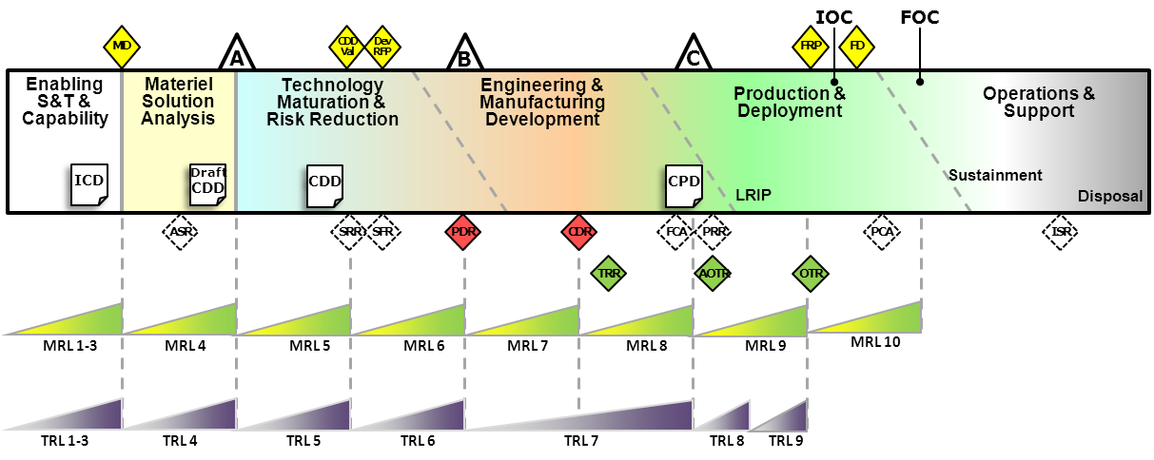
Figure 3-1. Relationship of MRLs to Decision Points, Milestones, Technical Reviews, and TRLs

3.2 Manufacturing Readiness during Pre-Systems Acquisition
Pre-systems acquisition occurs before Milestone B. It ends with a decision to initiate a program of record⁽⁾ that is based upon the transition of mature technologies with manageable risk. Thus, the acquisition community expects that labs will provide technology mature enough to transition smoothly (i.e. meet cost, schedule and performance requirements) into designs.
For all technology development project managers, consideration of manufacturing risk and issues should begin early in TMRR and intensify as the technology matures so that manufacturing maturity is sufficient at the time of transition to support rapid and affordable incorporation into a system. Some manufacturing-related best practices for technology development project managers are as follows:
- Include manufacturing subject matter experts in all systems engineering technical reviews
- Perform a baseline assessment of manufacturing readiness early in the program to determine maturity based on the MRL criteria (include the transition customer in this process)
- Work with transition customer(s) to identify the target MRL that will be acceptable for transition (e.g., MRL 6 at Milestone B) and include this information in the Technology Transition Agreement
- Use the results of the baseline assessment to set priorities and develop an MMP that will reach the target MRL in time to support transition
- Plan and fund to ensure that both the target MRL is achieved within budget at transition
- Perform a final assessment of manufacturing readiness to confirm the target MRL has been reached and identify any remaining risks to be mitigated (again, include the transition customer in this process)

3.2.1 Materiel Solution Analysis Phase
The Materiel Development Decision marks the start of the MSA Phase. This presents the first substantial opportunity to influence systems design by balancing technology opportunities, schedule constraints, funding availability, system performance parameters, and manufacturing feasibility. The technical approach for system development should be driven by knowledge of the manufacturing maturity and risk of the various technologies under consideration as well as their associated performance maturity. Two systems engineering reviews, the Alternative Systems Review (ASR) and the Initial Technical Review (ITR), should be conducted during MSA.
This phase refines the initial concepts by conducting an AoA to examine potential materiel solutions with the goal of identifying the most promising option that satisfies the capability need. An AoA is a comparison of the operational effectiveness, suitability, and life-cycle cost of alternatives. The AoA also plays a role in crafting a cost-effective and balanced evolutionary acquisition strategy.
MSA ends when the AoA is complete and a draft AS has been developed for the proposed materiel solution. The rationale for the proposed evolutionary acquisition strategy would be documented as part of the AS. Manufacturing subject matter experts should participate in the AoA and the development of the AS
, by conducting assessments of manufacturing readiness (MRL 4) for each competing materiel solution being examined in the AoA. Special emphasis should be given to the proposed materiel solution to analyze feasibility from a manufacturing perspective and determine manufacturing resources needed. Sources of data may include technology and mission area plans and roadmaps, market research, and early evaluations of technology maturity. Key considerations include:
- Manufacturing capability, capacity, and feasibility
- Identification of manufacturing technologies and processes not currently available and risks associated with development

- Cost and schedule impact analyses to support trade-offs among alternatives
- Investments needed to create new industrial capabilities
- Risks of new program performance capabilities vs. planned cost and schedule
The results of the assessment are key emphasis areas for the ASR because the ASR highlights all technical issues that should be considered at the Milestone A Defense Acquisition Board (DAB) selection of the preferred approach. The ASR is conducted near the end of the AoA process. It ensures the one or more proposed materiel solution(s) are cost effective, affordable, operationally effective, and suitable, and can be developed to provide a timely solution to a need at an acceptable level of risk. As such, manufacturing-related readiness criteria should be addressed during this review and manufacturing risk associated with each of the alternatives should be identified. Risk should be based on how closely the alternatives meet the MRL 4 criteria and the degree of difficulty to meet MRL 6 criteria by the completion of TMRR.
The ASR should also identify key system elements that two or more competing teams will prototype after Milestone A. The intent is to reduce technical risk, validate designs, validate cost estimates, evaluate manufacturing processes, and refine requirements. The most feasible and representative materials, manufacturing processes, and facilities should be used to produce prototypes.
Prior to Milestone A, an AS is developed for a proposed materiel solution determined by the ASR. Because impactful changes in manufacturing capability can occur between assessment of manufacturing readiness performed for the AoA and the Milestone A review, it may be necessary to update the assessment so that the most up-to-date information will be in the AS and used as the basis of the Milestone Decision Authority’s (MDA’s) decision.
Other important outputs of the assessment of manufacturing readiness of the proposed materiel solution include inputs to the following:
- Investments required for manufacturing technology projects
- Definition of development increments
- Systems engineering reviews during TMRR
- Systems Engineering Plan
- Risk reduction plans
- Quality plans
- Contracting strategy for TMRR
- Program management reviews during TMRR

3.2.2 Technology Maturation and Risk Reduction Phase
The Milestone A decision point marks the entry into the TMRR Phase of acquisition. TMRR is a focused effort to mature, prototype, and demonstrate technologies in a relevant environment. The purpose of this phase is to reduce technology risk and to determine the appropriate set of product technologies and manufacturing capabilities to be integrated into a full system.

While it is not expected that contractors would have a complete production line and supply chain established this early in a program, key knowledge must be obtained on critical manufacturing processes, production scale-up efforts, and potential supply chain issues. The results of the assessment of manufacturing readiness performed during the MSA Phase should be used as a baseline reference for this activity. It is also possible that some technology development activities were not assessed during the MSA Phase. In that case, it is a best practice to conduct an assessment early in the TMRR Phase to establish a baseline. Technologies identified to have a maturity level less than MRL 4 at the start of this phase require special attention for maturation and risk mitigation in order to meet MRL 6 by Milestone B.
Three major systems engineering reviews are normally conducted during this phase, the System Requirement Review (SRR), the System Functional Review (SFR), and the Preliminary Design Review (PDR). If a Technology Readiness Assessment (TRA) is completed just prior to Milestone B. When feasible, this TRA should be closely coordinated with the assessment of manufacturing readiness conducted at that time. Manufacturing subject matter experts should participate in the TRA process.
TMRR essentially ends in a decision to release the development RFP for the system when a low risk entry into EMD is achievable. It is expected that technologies will be TRL 6 or better by the end of this phase; manufacturing capabilities should also be at least MRL 6. Key risk considerations for the assessment at the end of the TMRR Phase include:
- Manufacturing processes and techniques not currently available
- Probability of meeting the delivery date (e.g., for EMD prototypes)
- Design producibility risks
- Potential impact of critical and long-lead time material
- Production equipment availability
- Production unit cost goal realism
- Manufacturing capability analyses and cost and schedule impact analyses to support trade-offs
- Recommendations for production testing and demonstration efforts
- Methods for conserving critical and strategic materials and reducing reliance on foreign sources
The output of the assessment is the basis for knowledge of manufacturing maturity and risk for all technologies under development. This is a vital part of the decision process at Milestone B, therefore, the assessment results must indicate the key risk areas for the PDR. This technical review ensures the system under review has a reasonable expectation of satisfying the requirements within the currently allocated budget and schedule. PDR produces a report detailing all technical risk and therefore is a key input to the Milestone B DAB (or equivalent) meeting that initiates a program of record. The assessment of manufacturing readiness can provide input for selection criteria for the preferred prototype or competing design, if any remain, by highlighting if and where any risk areas fall short of MRL 6. Discussions of the risks these shortfalls pose to the program, and discussions of the status of efforts to mitigate those risks should be part of the PDR report.
If any risk areas are found to fall short of MRL 6, three basic choices are available to the program manager:
- Request a delay in the Milestone B decision point to allow time to reduce the manufacturing risk
- Select alternative, lower risk manufacturing approaches
- Carry higher manufacturing risk into the Milestone B DAB meeting and submit an MMP. The plan should include funding requirements.
Other important outputs of the assessment of manufacturing readiness include inputs to the following:
- Investments in long-lead items
- Design reviews during EMD
- Industrial base assessment and the AS
- The Systems Engineering Plan
- The PDR report
- Risk management plans
- Contracting strategy for EMD
- Quality plan updates
- Manufacturing plans
- Program management reviews during EMD

3.3 Manufacturing Readiness During Systems Acquisition
The systems acquisition phase that begins after Milestone B encompasses all detailed design and manufacturing activities needed to deliver the requirements defined in the Capability Development Document (CDD) and later the Capability Production Document (CPD). It ends after an FRP decision has been made and sufficient quantities have been fielded to carry out their mission. By considering manufacturing risks and issues in pre-systems acquisition, a strong foundation will be formed for mitigating those risks in systems acquisition. The effect of addressing manufacturing maturity progression in this phase will have significant impact on the ability of the program to forecast and achieve the cost, schedule, and overall quality requirements, of the products as they transition to the warfighter. Some manufacturing related best practices for acquisition program managers are as follows:
- Plan and fund to ensure that manufacturing maturity at CDR, Milestone C, and FRP are achievable within budget
- For any element not assessed in the TMRR Phase, perform an initial assessment of manufacturing readiness early in EMD to baseline what the risks are and what efforts are needed to manufacturing maturity requirements
- Use the baseline information to set priorities and develop an MMP that will reach the target MRL in time to support low rate and full rate production
- Incorporate the management of manufacturing maturity into the program management process (e.g. similar to tracking cost and schedule activities) to ensure adequate progress is being made
- Perform a final assessment of manufacturing readiness to confirm appropriate manufacturing maturity has been reached and that the program is ready to transition to the next phase
- Develop and implement a fully funded MMP to reduce risk to acceptable levels where the targeted MRLs have not been achieved
- Include manufacturing subject matter experts in all systems engineering technical reviews
- Update all key decision makers in the acquisition management system with results of manufacturing maturation efforts to achieve manufacturing maturity

3.3.1 Engineering and Manufacturing Development Phase
Milestone B determines whether a formal acquisition program will be launched and marks the entry point into the EMD Phase. This phase completes the development of a system, leverages design considerations, completes full system integration, develops affordable and executable manufacturing processes, and completes system fabrication, test, and evaluation. The systems engineering reviews normally conducted during this phase are the CDR, the Test Readiness Review (TRR), the System Verification Review (SVR) (Functional Configuration Audit) and the PRR.
From a manufacturing perspective, the purpose of the EMD phase is to ready the acquisition program for production by completing manufacturing risk reduction activities that are reflected in the acquisition strategy. The manufacturing planning that was developed in the previous phase should be refined in EMD and significant program emphasis should be placed on achieving manufacturing maturity prior to the decision point at which this phase ends (either authorization to enter LRIP, or FRP for systems that do not require LRIP). The appropriate levels of maturity for LRIP are the MRL 8 criteria and metrics and MRL 9 are the appropriate criteria and metrics for FRP. These should be reflected in the acquisition program baseline.
During EMD, assessments of manufacturing readiness are conducted to identify remaining risks on the design and manufacturing maturity prior to a production decision. These should be conducted in concert with the CDR and also later in EMD just prior to the Milestone C decision. Sources of data may include technical reviews and audits, Program Support Reviews, pre-award surveys, incremental PRRs, industrial base analyses, trade-off studies, tooling plans, make-or-buy plans, manufacturing plans, and bills of material. The assessments should focus on program-wide manufacturing risks such as fabrication, assembly, integration and test operations; supply chain performance; the adequacy of manufacturing planning; the efficacy of manufacturing management systems; adequacy of funding for manufacturing risk reduction efforts; and other factors defined in MRL thread descriptions. Articles manufactured on a pilot line during EMD should be made using production materials, components, tooling, facilities, and personnel. Key considerations include:
- Industrial base viability
- Probability of meeting the delivery date (e.g., for qualification units)
- Design completion and stability
- Quality and maturity of processes
- Manufacturing costs
- Supply chain management
- Quality management
- Facilities
- Manufacturing skills availability
The output of the assessment for CDR should be included in the CDR Report to the MDA. This assessment assures adequate progress is being made toward MRL 8 by Milestone C. It should identify any area where MRL 7 has not been achieved and delineate the efforts necessary to mitigate the associated risks.
The program PRR is a Systems Engineering technical review at the end of EMD to ascertain if a program is ready for production. The PRR assesses whether the prime contractor and major subcontractors have completed adequate production planning and that there are no unacceptable risks for schedule, performance, cost, or other established criteria. An assessment of manufacturing maturity and risk, conducted by manufacturing subject matter experts, should be a principal input to the PRR. In verifying the system product baseline, the PRR requires adequate manufacturing maturity has been demonstrated; manufacturing processes are stable and have been demonstrated on a pilot line; adequate processes and quality metrics are in place; and the manufacturing plan is up-to-date with sufficient planning to address LRIP operations (i.e., facilities, tooling and test equipment capacity, personnel development and certification, process documentation, inventory management, supplier management, etc.).
The assessment of manufacturing readiness should highlight for the PRR any areas where an element or a key manufacturing aspect falls short of MRL 8 requirements; discuss the risks and the status of efforts to mitigate these risks; and estimate the schedule or funding changes required to correct any significant shortfalls.
If any key aspects of the overall program manufacturing preparation are found to fall short of MRL 8, there are three basic choices available to an acquisition program manager:
- Request a delay in the Milestone C decision point to reduce manufacturing risk
- Select an alternative design that would use a lower risk manufacturing approach
- Carry higher manufacturing risk into the Milestone C review and submit a MMP along with the results of the assessment of manufacturing readiness
Other important outputs of the assessment of manufacturing readiness include inputs to the following:
- Risk management plans
- Quality plan updates
- Manufacturing plan updates
- Systems Engineering Plan
- Contracting strategy for production
- ICAs and the AS
- Program management reviews after Milestone C

3.3.2 Production and Deployment Phase
At Milestone C, the decision is made to proceed into the Production and Deployment Phase. The purpose of the Production and Deployment Phase is to achieve an operational capability that satisfies mission needs. A program may be structured with either one or two major decision points for this phase. The MDA for Milestone C will decide if the program will enter LRIP or FRP. The target MRL for LRIP is 8 while the target is 9 for FRP.
If LRIP is required, to the extent practical, this production effort should be performed in a manner that uses designs, tooling, materials, components, facilities, and personnel that are representative of the production environment. The FRP decision requires that manufacturing risk is understood and that the manufacturing processes for the system be capable, in statistical control, and affordable. Prior to the FRP decision, a manufacturing readiness assessment should be conducted to ensure any outstanding risks will not impact the ability of the program to deliver FRP requirements.

Conducting Assessments of Manufacturing Readiness

4.1 Introduction
This section provides general guidance and describes best practices for performing assessments of manufacturing readiness. It is organized around the key steps in the process as shown in Figure 4-1.

Figure 4-1. Sample Process Flow for Conducting
an Assessment of Manufacturing Readiness
An assessment of manufacturing readiness is an important tool for evaluating manufacturing maturity and risk that is most useful in the context of a broader manufacturing risk management process. These assessments should lead to actions such as setting goals for increased manufacturing maturity and reduced manufacturing risk, creating action plans and funding estimates to reach those goals, reaching decisions about the readiness of a technology or process to transition into a system design or onto the factory floor, and reaching decisions on a system’s readiness to proceed into the next acquisition phase. Therefore, an assessment of manufacturing readiness should compare the status of the key program elements to a nominal MRL appropriate for the stage of the program, describe the risk associated with elements that fall short of the goal, and lay the foundation for manufacturing risk mitigation planning and investment.

4.2 Determine Initial Assessment Scope
The program/project office should establish the initial schedule and scope for the assessment in conjunction with the prime contractor or equivalent thereof.
- At Milestone A, the proponents of the alternatives evaluated in the AoA, including the proposed materiel solution, should fulfill the role of the prime contractor. Since the AoA is conducted by an entity independent of the program, the program/project office may not be established this early in the acquisition process. In that case, the DoD Component should identify who will carry out the responsibilities associated with the assessment of manufacturing readiness.
- At Milestone B, there will be prime contractors associated with every system-level preliminary design still in competition. However, there may be circumstances where the system-level preliminary design is not the starting point for the detailed design effort in EMD because a new technology has become available or there has been a change in the requirement. Therefore, assessments of manufacturing readiness are also applicable to the prime contractors associated with these situations if the risk warrants it.
- At CDR, there will be a prime contractor associated with the detailed design.
- At Milestone C, the prime contractor will be associated with the system-level PRR.
- At FRP, there will be a prime contractor associated with production.
Program/project personnel are likely to need training and additional information. The MRL criteria, threads, tutorials, tools and other information can be found on the DoD MRL site.
The scope of the assessment and the associated MRL target will vary as a function of the stage of the life cycle⁽⁾ and specific program requirements. For example, one would not expect the same manufacturing maturity requirements for a low rate production item (e.g., a satellite) as compared to a high rate production program (e.g., ammunition, radios). However, in both cases there should be an adequate demonstration of manufacturing maturity, albeit different specific requirements, to ensure the program can achieve the cost, schedule, and performance requirements at the next level. Some examples that demonstrate how the scope may change are as follows:
- During the MSA Phase, an assessment may be conducted for a particular prototype conceptual design in the context of an AoA. Early consideration of producibility and affordability of a particular concept allows for adjustments to design margins before expensive testing or commitment to the achieved performance makes those changes irreversible. It also helps identify manufacturing technologies/capabilities that need to be developed in the next phase. The nominal MRL target would be 4 as an entrance criterion for Milestone A.
- In the early stages of TMRR, an examination of the producibility of a proposed design allows for trades on cost, performance, and schedule to be accomplished when it is significantly easier to make changes and where changes potentially have a greater impact on key performance metrics. The nominal MRL target would be in the range of 4 to 5.
- In a source selection for EMD, assessments can aid in determining the maturity of the design relative to the offeror’s ability to achieve projected cost or schedule targets. The assessment would define manufacturing progress and risk for the next phase and ensure prototype hardware was produced in a relevant environment. The use of criteria associated with MRL 6 can assist in determining risks during EMD as a program moves toward CDR.
- At CDR, it is necessary to examine integration processes such as assembly, installation, and test. When a subsystem and/or component (e.g., battery/circuit card) is built by a prime contractor or supplier, both assembly and test processes should be examined in an integrated process flow. At the system level (e.g., missile), components require assembly processes, intermediate test processes, installation, and final acceptance testing. All work breakdown structure levels must be considered to effectively gauge the ability to meet projected cost and schedule targets. The criteria associated with MRL 7 reflect a maturity level consistent with CDR requirements approaching a low rate production decision.
- If the assessment is being conducted on a pilot line, emphasis will be placed on understanding what the production capability and capacity is to meet program objectives in cost, schedule (e.g., low rate production rates) and performance and to anticipate whether there will be any problem with full rate production processes. The criteria associated with MRL 8 reflect a level of maturity of a program as it moves toward Milestone C full rate production.

4.3 Determine Assessment Taxonomy and Schedule
The assessment taxonomy encompasses what will be assessed, where the assessments will take place, and who will lead the assessment.
The government program/project office, in conjunction with the prime contractor, should make an early determination of potential issues by breaking out system, subsystem, or component level for analysis and then determining the applicability of components for evaluation. Consideration should also be given to associated test and assembly processes. The following questions have been developed to assist in the determination of elements to be assessed. All critical technologies, immature manufacturing processes, and other significant areas of the work breakdown structure or bill of materials should be subject to the following filtering questions. Any “yes” responses imply that an assessment of manufacturing readiness may be needed for that element to categorize the degree of technical and manufacturing risk.
Materials: Are there materials which have not been demonstrated in similar products or manufacturing processes?
Cost: Is this item a driver that significantly impacts lifecycle cost (development, unit, or operations and support costs)? Is the technology new with high cost uncertainty?
Design: Is the item design novel or does it contain nonstandard dimensions or tolerances or arrangements?
Manufacturing Process: Will the item require the use of manufacturing technology, processes, inspection, or capabilities that are unproven in the current environment?
Quality: Does the item have historical/anticipated yield or quality issues?
Schedule: Does this item have lead time issues or does it significantly impact schedule?
Facilities: Does this item require a new manufacturing facility or scale up of existing facilities (i.e., new capability or capacity)?
Supply Chain Management: Does the item have anticipated or historical sub-tier supplier problems (e.g., cost, quality, delivery)?
Industrial Base: Does the item have an industrial base footprint with critical shortfalls or is this a critical item manufactured by a sole or foreign source?
It is rarely feasible to visit every supplier of every material, component, and assembly to examine the status of their key manufacturing processes. Some elements should be assessed on-site and others may utilize alternative approaches. The type and depth of the assessment is determined by the risk level of the element. On-site evaluations are typically reserved for the locations where one or more of the following apply:
- The highest percentage of manufacturing cost is incurred
- Final assembly and test is conducted
- The most sensitive manufacturing tasks are accomplished
- The materials, components or subsystems that are the least technologically mature are produced or availability issues exist
- Known significant problems or risks (low yields, high costs, immature manufacturing processes, etc.) exist
Normally, the government program/project office will lead the assessments at the prime contractor(s) and the prime contractor(s) will lead the assessments for its suppliers. Prior to Milestone A, site visits might not be possible since there rarely is any hardware to support the conceptual designs. Under special circumstances, currently running production lines may be visited if it is anticipated that similar process and tooling will be utilized.
The schedule is typically driven by a variety of considerations including timing of acquisition milestone reviews or program baseline reviews; availability of qualified team members; contractor scheduling concerns; etc. For a small technology demonstration project, an assessment might take a single day at one contractor’s facility and require a team of two or three persons. Conversely, a major acquisition program may require multiple site visits over a period of months and involve a larger team, not all of whom will go to every site.

4.4 Form and Orient Assessment Team
Assessments of manufacturing readiness are typically performed by teams and the government program/project office is responsible for forming them. It is a best practice for the government program/project office to lead the team at prime contractors and the prime contractor to lead the team for the sub-tiers. When the prime contractor leads the assessment, it will determine who it wants to include on the team; however, the program/project office should add its own representatives. Team members should be experienced and knowledgeable in the areas of manufacturing engineering, industrial base, quality, supply chain, design, systems engineering, and production to identify potential manufacturing constraints, risks, and the capability of the technology and industrial base to execute the manufacturing efforts. This experience and knowledge is also important for tailoring the reviews to the specific circumstances of the program. Technology or process subject matter experts may be required to identify issues not expected to be uncovered by general manufacturing, industrial base, quality, and production experts.
Team selection can begin once the scope and a rough schedule of activity is developed. These teams will vary in size depending on the scope of the assessment. Sub teams may be put together to focus on various subsystems or technologies. The team composition will normally lean heavily toward program/project office and service manufacturing subject matter experts. Representatives from DoD staff organizations may participate as well, if the assessment is being performed on an acquisition program approaching a milestone decision.
Strong consideration should be given to including a level of independence for several reasons:
- It adds credibility to the assessment
- It enables alternative views from others who may have a different perspective
- It provides an opportunity to obtain opinions from subject matter experts not normally available to the program
- It promotes a cross-flow of information well beyond the program office
Such a level of independence may be obtained by a variety of means, at the discretion of the service and the program office. Some ideas for achieving independence are as follows:
- Appoint a co-chair independent of the program
- Include subject matter experts independent of the program
- Use an independent technical authority to review the results of the assessment
Team members from outside the program/project being assessed should familiarize themselves with the program/project. They will need to understand the purpose of the assessment, the objectives, and the status of the program, critical technologies, critical manufacturing processes, configuration of hardware, and roles and locations of key contractors and suppliers. This can usually be accomplished by reviewing existing briefing materials, contracts, and progress reports and through interaction with program/project personnel.
The program/project office should consider contacting the appropriate office of the Defense Contract Management Agency (DCMA) to gather information on the contractor’s current and past performance. DCMA personnel interact with most OEMs frequently and with their key suppliers and may have very useful information about quality problems and other risk areas. Consider including DCMA personnel in on-site evaluation teams if they are available.
It is also important for the program/project office to set expectations for team members early in the process. The following are some of the key areas to be covered:
- Initial schedule
- Format and timing of reporting their results to the team
- Standards of behavior at the contractor’s facility
- Security clearances or nondisclosure agreements
- Personal preparation
- The need for a detailed understanding of their assigned area and the role of shop floor observations and off-line discussions with contractor personnel
- Responsibilities after the on-site review

4.5 Orient Contractors Being Assessed
The leader of the assessment (either the government program/project office or the prime contractor) should orient the contractor(s) to be assessed before the assessment occurs. This orientation may involve including contractor personnel in planning meetings as well as providing the contractor with an orientation package that includes:
- The MRL criteria and threads
- Directions to additional materials on DoD MRL site
- Self-assessment questions
- An indication of technologies or processes of special interest that should be included in the self-assessment
- For on-site assessments, the orientation package should also include:
- The questions the assessment team will use
- A straw man agenda for the assessment visit
- Evidence to be provided at the onsite visit (e.g., process maps, proposed manufacturing plan, process capability data, yield data, technology development plans, risk reduction plans, value stream analysis, etc.)
- High-interest areas where shop floor visits and/or discussions with contractor experts will be desired
- Expectations of resources, time, etc. required for the assessment
Make arrangements with the contractor for an assessment team meeting room to be available where private discussions can be held and team members can record their observations. Also, make arrangements with the contractor for assessment team members to bring computers into the facility to facilitate the capture of their observations in electronic format.

4.6 Request Contractors Perform Self-Assessment
The leader of the assessment should ask the contractor(s) to conduct a self-assessment to address the following basic questions:
- What is the current MRL for each of the key technologies being developed and each key manufacturing process being used?
- If currently funded activities continue as planned, what MRL will be achieved for each key technology or process by the end of this acquisition phase or program? What activities and schedules are required to achieve this MRL?
- In the case of an ATD or ACTD, what MRL would be sufficient for you or an OEM using your technology to commit to it in a product baseline design?
In the case of on-site assessments, the contractor should be prepared to brief the results to the assessment team when it is on-site. For companies that provide key components or subassemblies and for which a site visit is not feasible, the contractor’s written self-assessment should be analyzed by the assessment team.

4.7 Set Agenda for Site Visits
The leader of the assessment should set the agenda for site visits. Site visits are intended to provide a more detailed understanding than can be gained from briefings and documents. Assessments of manufacturing readiness should be structured in such a way as to take maximum advantage of discussions with contractor experts and first-hand observations of the status of shop floor activities. A balance must be struck between the time spent in briefing rooms and the time spent making observations in the contractor’s facility and having discussions with individuals and small groups of the contractor’s personnel. A typical agenda for a review may contain the following elements:
- Contractor welcome, review of agenda, assessment schedule. and orientation to the facility
- Introduction of assessment team and contractor personnel
- Briefing to contractor describing objectives and expectations for the on-site visit
- Contractor overview and discussion of the results of their self-assessment
- Shop-floor visits to key areas by individuals or small groups
- One-on-one or small group discussions between assessment team members and contractor subject matter experts focused on key areas
- Private meeting of assessment team to record and discuss observations
- Out-briefing by assessment team to contractor

4.8 Conduct the Assessment of Manufacturing Readiness

4.8.1 Review the Self-Assessment
The assessment team should initiate focused dialog at the component, test, and/or assembly process based on complexity, location, personnel availability, etc. In larger assessments, specific technologies, assemblies, subsystems, or processes should be assigned to individuals or sub teams.
The MRL criteria are used for determining manufacturing maturity. The leader of the assessment should review the self-assessment and examine targeted components, subsystem and system-level test and assembly processes with respect to the threads. These threads have different applicability at various times during a product development life cycle. The threads can apply at each component, subsystem, system, and eventually at the program level. They should be used to guide examination of various data sources such as process maps, work instructions, and factory tours to assign an MRL to a technology, component, or subsystem.
A series of knowledge-based questions derived from the MRL criteria and threads are typically used to guide the assessment process and determine the MRL of specific elements that are embodied in hardware (e.g. materials, components, assemblies, subsystems). The questions are adaptable to any program and have been incorporated into tools that store the MRL data for the self-assessment. The questions and tools can be found at the DoD MRL website.

4.8.2 Conduct Assessment
When conducting an assessment of manufacturing readiness, there should be a well-defined hierarchy among the elements assessed. The hierarchy should start at the system level and flow down to the lowest component that forms the smallest unit for examination. The assessment team should determine the MRL threads applicable to each element in the hierarchy and identify the needed system level test and assembly processes that require an MRL assignment. This includes test and assembly steps that would be included in a subsystem or component fabrication. For example, a Printed Wiring Board (PWB) has several assembly and testing steps during the fabrication of the board. That PWB would be included in a subsystem buildup in an avionics box (i.e., radar) that may require a next higher level assembly and test process.
The threads also serve as a guide or completeness check to alert the assessment team of the need to examine other areas. For example, the self-assessment may be for a missile guidance system (as initially determined by the taxonomy in Section 4.3) that was reported to be MRL 3 but targeted to be MRL 4. Additional detail may be needed to discern why it was assessed at MRL 3 and identify the critical steps needed to mature it. Therefore, further assessments may be necessary at the component level as shown in Figure 4-2.

Subsystem | MRL Criteria | Observations | Most Critical
Guidance | 3 | - Lacking detailed process information  - Key suppliers identified; need key performance parameters  - Need detailed process plans | - Detector from Supplier A  - Design and production issues  - No alternate source
Date Processor | 3 | - New processor architecture  - Immature design tools  - New attachment processes needed | - Board supplier cannot test at its site  - Low yields on initial run
Propulsion | 6 | - Same as other systems in use  - New component scheme | - Revalidate manufacturing process  - Supplier ability to handle increased rate
Air Vehicle | 7 | - Same supplier as System X  - Need to test new mating and assembly processes at the prime | - No critical items
Test Plan | 6 | - Several instances of redesign work and new test processes | - New test strategy and plan  - What will new design incorporate  - Manufacturing experience vital
Figure 4-2. Example of Added Detail Derived from Site Visits
During the assessment process, a component or subsystem may be found to be more complex than originally thought, so an even more detailed analysis, or “deep dive,” may be warranted. If the assessment team determines further examination of critical components is necessary, the MRL threads should be applied at that level. Sub-components are examined along with process steps, and an MRL is determined for this final sub-tier element. Team members should seek existing, objective documentation that supports assessment results in key areas (e.g., plans, yield data, reports, briefings, work instructions).
In determining the manufacturing readiness of a component or subsystem, use the MRL criteria to structure the review and establish targets for each thread/sub-thread. If the target criteria are not met, utilize the risk matrix approach in the “DoD Risk, Issue, and Opportunity Management Guide for Defense Acquisition Programs” to analyze and characterize the risks. The team assesses the number, likelihood, and severity of the risks to determine the manufacturing readiness of the component or subsystem.
Finally, the assessment team should include the actions necessary to achieve the target level in time to transition a technology or support a milestone decision with manageable risk.

4.8.3 Complete the Assessment
DCMA personnel should be asked to provide their perspective and insight on the contractor’s presentations and status. If the contractor was unable to provide adequate information to support an assessment in a key area, assign an action item for the contractor to provide the information by a specific date.
Near the end of the assessment, the team should meet at the contractor’s facility to discuss and capture its observations and impressions. The team should also provide an out brief to the contractor highlighting strengths and risks, MRL achievements compared to targets, and action items. Finally, the hospitality and cooperation of the contractors should be recognized.
MRL assessments are not a simple go/no-go gauge. Therefore, assigning a single MRL to an entire technology or weapon system often has little value. Even in a relatively simple case, where an assessment is being accomplished on a single technology with perhaps a half-dozen hardware components, it is likely the MRL will vary widely from component to component and perhaps even manufacturing process by manufacturing process for a specific component. Some components may be off-the-shelf, standard hardware, or made with well-established materials and processes from reliable suppliers, thus perhaps having an MRL in the range of 8 to 10. Other components may incorporate new design elements that move well beyond the proven capabilities of a key manufacturing process and perhaps are at MRL 4.
Using a “weakest link” basis, a technology or system would have to receive an overall MRL that reflects the element of that technology that had the lowest level of readiness, in this case, MRL 4. In many instances, this approach could be misleading and give the impression of an overall level of risk greater than the actual situation. For assessments of more complex subsystems and systems, this simplification becomes even less useful since it is unlikely that every element is going to be, for example, at MRL 6 by Milestone B.
Therefore, the assessment report (as described in section 4.9), should contain a bottom-up assessment of the relative manufacturing readiness at the system, sub-system and component level. Findings for lower level components can be fit into a format for analysis and decision making at higher levels of the program as shown in Table 4-1. Each MRL (at any level) should be identified to provide insight into specific risks.

4.9 Prepare the Assessment Report
The results should be documented by team members in a format agreed to in advance. Except in the simplest cases, it may not be feasible for the team to agree on an assessment while on-site at the contractor’s facility. Usually some analysis is required by the assessment team after site visits are complete to clearly define the manufacturing readiness and risk status of the key technologies and manufacturing processes and to put the identified risks into a program context. These final results are then typically documented in a written report or out-brief containing the following:
- A description of the technology, component, sub-system or system which identifies the elements that were assessed; the key objectives of the development effort; and a discussion of the current state of the art
- A discussion of the companies which are responsible for the elements that were assessed
- A list of team members
- Dates and locations of site visits
- A description of the manufacturing processes for the elements that were assessed
- The manufacturing readiness for each element that was assessed
- Areas where manufacturing readiness falls short of the MRL criteria
- Identify key factors
- Describe driving issues
- Plans to achieve the target MRL
- Assessments of the type and significance of risk to cost, schedule or performance
- Assessments of the effectiveness of current risk mitigation plans
- Address right issues?
- Timely?
- Adequately funded?
- Probability of success?
- Options for increased effectiveness?
The government program/project office is the primary audience for the report since it forms the basis for managing manufacturing risk. In general, the report establishes a manufacturing maturity baseline that should be used to either create a plan to increase manufacturing readiness/maturity sufficiently to support transition to the next phase of acquisition or to demonstrate that the technology is ready for transition. The report may also provide information to an MDA determination of whether the level of manufacturing risk supports Milestone approval.
When actual MRLs are compared to target values based on the stage of the life cycle, the report provides a basis for an analysis and assessment of the risks associated with each manufacturing thread. Cost, schedule or performance manufacturing risks that are not resolved must be defined and require manufacturing maturity plans. These plans should include a description of the approach to resolve the risk, cost estimates, resources available, and schedule impacts. The manufacturing maturation plan is normally delivered along with the assessment report. See section 5.

Manufacturing Maturation Plans and Risk Management

5.1 Introduction
The purpose of an assessment of manufacturing readiness utilizing the MRL criteria is to analyze current conditions and to identify manufacturing risks in order to assist the program/project manager in creating a plan or options to reduce or remove those risks. Identifying risk is a key part of developing mitigation efforts; it is a key enabler of program success. Risk management includes risk planning, risk assessment, risk handling and mitigation strategies, and risk monitoring approaches. Thorough assessments of maturity, development of maturation plans, and the use of technology transition plans are fundamental tools for mitigation. See the following for further information on risk management:
- DoD Risk Management Guidebook
- DoD Risk Management Community of Practice
- Risk Management Continuous Learning Management Module
A key product resulting from an assessment of manufacturing readiness is the MMP, which addresses the manufacturing risk and provides a mitigation plan for each risk area throughout the duration of the program/project, including supplier and sub-tier supplier risk management shortfalls. Every assessment of manufacturing readiness should have an associated MMP for those areas where the MRL has not achieved its target level.
A low MRL assigned to a component is not necessarily bad at an early stage of acquisition. By identifying the risk area(s), necessary investment can be channeled to attain the target MRL by the time of transition to the next phase of the program/project. As a result of risk identification, the program/project can formulate and execute MMPs before the risks become severe. A manufacturing maturity shortfall in an element can be easy or difficult to fix. The following information is needed to decide whether a technology or weapon system is ready to move to the next phase of its life cycle.
- Identification of any elements (technologies, components, assemblies, subsystems, processes, etc.) that have not reached the target MRL
- Understanding of the potential impact if the element fails to mature to the target level as well as how difficult, time consuming, and expensive it will be to bring the element up to an acceptable level of maturity or develop an adequate work around
The remainder of this section describes activities to address risk. The format of the MMP which serves as the manufacturing risk mitigation plan is shown (Section 5.2).Finally, best practices for manufacturing risk mitigation are listed (Section 5.3).

5.2 Development of a Manufacturing Maturation Plan
In conjunction with the contractor, the program/project office should prepare an MMP that covers all manufacturing risk areas. The MMP should be delivered along with the results of the assessment of manufacturing readiness. The following outline for an MMP includes the most essential items in planning for the maturity of a specific element of assessment found to be below its target MRL:
- Title
- Statement of the problem
- Describe the element of assessment and its maturity status
- Describe how this element of assessment would be used in the system
- Show areas where manufacturing readiness falls short of target MRL including key factors and driving issues
- Assess type and significance of risk to cost, schedule or performance
- Solution options
- Benefits of using the preferred approach
- Fall-back options and the consequences of each option
- Maturation plan with schedule and funding breakout
- Key activities for the preferred approach
- Preparations for using an alternative approach
- The latest time that an alternative approach can be chosen
- Status of funding to execute the manufacturing plan
- Specific actions to be taken (what will be done and by whom)
- Prototypes or test articles to be built
- Tests to be conducted
- Describe how the test environment relates to the manufacturing environment
- Threshold performance to be met
- MRL criteria to be achieved and when it will be achieved

5.3 Risk Management Best Practices
The following best practices are applicable to both acquisition program managers for all programs of record and managers for all technology development projects and demonstrations and pre-systems acquisition programs intending to transition to the TMRR Phase of acquisition at Milestone A or into a program of record at Milestone B or C. The best practices are categorized into five areas.
- Recognize the importance of manufacturing and mitigating manufacturing risk to the success of a program/project
- Accept manufacturing risk management as a basic responsibility, on par with the management of any other risk
- Recognize that mitigating manufacturing risk can be the key ingredient of success in transitioning a product or process technology to a program of record
- Recognize manufacturing risk and readiness as key factors in defining and achieving program/project cost, schedule and performance goals
- Manage manufacturing risk
- Incorporate the management of manufacturing readiness, risk, and cost into the basic fabric of managing the program/project
- Assess, plan, budget, and manage to reach manufacturing maturity and cost targets. For technology development projects, incorporate the target MRL (typically MRL 6) to support the technology transition plan. For programs of record, the target MRLs for CDR, LRIP, and FRP are 7, 8, and 9 respectively
- Conduct assessments of manufacturing readiness to increase the probability of program success and integrate the results into a broader effort to manage manufacturing risk. These assessments should lead to action-oriented decisions
- Prevent the adoption of a technology by a program of record if it has not reached an appropriate level of manufacturing readiness (normally MRL 6)
- Monitor the status and progress of manufacturing risk mitigation activities
- Know the MRL of every technology being considered for application in the program/project
- Assess and understand manufacturing readiness and risk early in each phase of an acquisition program to establish a baseline
- Include contractual Statement of Work (SOW) taskings (see Section 6) for the prime contractor and suppliers to support assessments of manufacturing readiness. Also include contractual SOW taskings for best practices that improve producibility, quality, and affordability and enable the assessment of manufacturing maturity
- Do not rely totally on contractor manufacturing assessments
- Incorporate manufacturing maturity examination and progress monitoring in management reviews, system engineering technical reviews, and progress reporting
- Utilize the manufacturing expertise of others to help mitigate manufacturing risk
- Use the manufacturing expertise available on product center manufacturing staffs and within the service/agency manufacturing technology programs to supplement staff
- Identify and access trained and experienced manufacturing subject matter experts outside of the service/agency
- Use DCMA as a source of information about strengths and weaknesses in a contractor’s manufacturing operations
- Develop program/project office staff skills in identifying and mitigating manufacturing risk
- Review the manufacturing readiness information and tools available on the DoD MRL site
- Support manufacturing training for program/project staff

Applying MRLs in Contract Language

6.1 Introduction
Like all other requirements, assessments of manufacturing readiness based on the MRL criteria must be included in contract language to be effective. During the initial stages of acquisition planning and risk identification, a determination should be made of the manufacturing requirements in the planned program. If hardware is being manufactured, the two key drivers in determining the manufacturing requirements are the current phase of acquisition and the overall complexity of the hardware. Once manufacturing requirements are identified, the team can then assess whether manufacturing readiness will be a significant discriminator for the source selection. Discriminators are those key requirements or program risks that separate offerors from each other during the proposal evaluation process.
If manufacturing readiness will be a discriminator between offerors, then appropriate language should be incorporated in Section L (Instructions to Offerors) and Section M (Evaluation Criteria) of the Request For Proposal (RFP) so it can be used during the source selection process. If manufacturing requirements exist, assessments of manufacturing readiness should be included in the Statement of Objectives (SOO) and in the resulting SOW, so they can be a formal part of the contract. Although most of the discussion in this section is oriented towards competitive acquisitions, this recommendation for SOO or SOW language also applies to sole source programs with manufacturing requirements. The acquisition team must determine the target MRL for the completion of the phase (e.g., MRL 8 for Milestone C). Once this is determined, the acquisition team can develop requirements, analyze and assess program risks, develop the overall acquisition strategy for the program, and develop the appropriate RFP and contractual language.
This section presents some ideas and strategies for ensuring assessments of manufacturing readiness based on the MRL criteria are treated effectively as a part of acquisition activities. It contains methods and examples on how to effectively implement the process for conducting an assessment of manufacturing readiness contractually in a program as part of RFP language (Sections 6.2 and 6.3), SOO language (Section 6.4), and SOW language (Section 6.5). These examples are meant to be tailored to reflect the complexity of the current phase of acquisition.

6.2 Strategies for Competitive RFP Language
If manufacturing readiness is a requirement and a source selection discriminator, the RFP should require the offeror’s proposal to document the results of an assessment of manufacturing readiness against the MRL criteria appropriate for the current phase of the program. The key decision factor should not be the current MRL, but the risk of achieving the final MRL target. Based on the assessment, the offeror’s proposal should identify the current MRL and then give an explanation of how the target MRL for each program element will be achieved by the end of the acquisition phase (e.g., MRL 8 for Milestone C). This information should be used to assess the risk of achieving the target MRL by completion of the proposed phase. The best approach to assess this risk is by assessing the contractors understanding of steps necessary to evaluate their MRL, the steps necessary to achieve the target MRL (e.g., Manufacturing Maturation Plans), and the risk associated with achieving those steps.
Section L of the RFP (Instructions to Offerors) will specify the content and any required format the offeror must submit to substantiate the process to achieve the target MRL. This will reduce the likelihood of misunderstandings between the offeror and government when discussing the program’s manufacturing risks and plans.
Example scenario for a program entering the Technology Maturation and Risk Reduction Phase:
The RFP will direct required offerors to prepare an overall, initial assessment.
The offerors shall have conducted a preliminary assessment of manufacturing readiness using the MRL 4 criteria found in the Manufacturing Readiness Level Deskbook. The results of this assessment shall be discussed in the proposal along with the assessment methodology the offeror used. The offeror shall explain how they plan to move forward from their assessed MRL to the MRL 6 definition that is expected at the end of the Technology Maturation and Risk Reduction. The offeror shall include enough detail for the government to understand all manufacturing risks that are expected and all risk mitigation efforts that will be necessary to achieve the final MRL 6 definition at the end of the phase. The offeror shall discuss how MRL 5 and 6 will be achieved within their plans and schedules.

6.3 Manufacturing Readiness RFP Language for Source Selection
Using assessments of manufacturing readiness in source selection requires language in three key sections of the RFP: Section L (Instructions to Offerors), Section M (Evaluation Criteria), and the SOO or SOW. Language should be inserted in Sections L and M only if manufacturing readiness will be a discriminator in the source selection. The SOO or SOW language should be included in all RFPs. The RFP content must be consistent among the contract requirements in the SOO or SOW (e.g. the target MRL and to conduct periodic assessments of manufacturing readiness during the contract period of performance), Section M (the criteria stating how the evaluation team will evaluate the offeror’s proposal to meet or exceed the target MRL), and Section L (the instructions for what information must be included in the proposal to allow the evaluators to properly evaluate whether the offeror meets or exceeds the target MRL).

Section L sample language:
Sub-factor/Component (TBD) – Manufacturing Readiness Level Demonstration

The offeror's proposal shall clearly and specifically identify those elements being assessed for manufacturing risk and the maturity of their current manufacturing capability using the criteria and process identified in the Manufacturing Readiness Level Deskbook (see http://www.dodmrl.org) and include the Manufacturing Readiness Level Deskbook in the RFP library of referenced documents). The contractor shall describe and substantiate the approach used. For any capability that is assessed below MRL ’X’, the offeror shall identify the current MRL and provide the supporting rationale for the assessment and the approach to achieve the target MRL.

Section M sample:
Sub-factor/Component (TBD) – Manufacturing Readiness Level Demonstration
The offeror’s proposal will be evaluated on the maturity of their current manufacturing capability, the adequacy of their supporting documentation to justify this maturity, and the adequacy of the offeror’s approach and plans to achieve the target MRL as described in the Manufacturing Readiness Level Deskbook.

Measure of Merit:
This sub-factor is met (i.e. is acceptable) when the offeror's proposal clearly identifies and substantiates its assessment against the MRL criteria and clearly demonstrates that its maturation plan is executable within the time and resources allocated to achieve the target MRL.

6.4 SOO Language For All RFPs
The RFP should specifically describe the respective intentions and roles of the government program office and offeror in preparation, analysis, and reviews of an assessment of manufacturing readiness. For example:
The offeror shall conduct assessments of manufacturing readiness utilizing the MRL criteria throughout the life of the contract using the Manufacturing Readiness Level Deskbook as a guide. The offeror shall use the process explained in Sections 4.0 and 5.0 of that document as a filter for identifying high manufacturing risk technologies or components and present appropriate risk analysis and associated maturation plans within the Integrated Master Schedule. The offeror shall specify in a SOW appendix the locations and frequencies of any assessments of manufacturing readiness, along with all the resources to perform or support these assessments. The offeror shall identify its approach for flowing down these requirements as a function of risk. The offeror shall address how assessments of manufacturing readiness will be executed and monitored to ensure achieving the target level in accordance with their Manufacturing Maturation Plans. The offeror should assume that the government will lead the assessment of manufacturing readiness at the prime contractor and the prime contractor will lead the assessments at the suppliers with government participation unless clearly specified differently in the proposal. The prime contractor shall plan to utilize subject matter experts (SMEs) in the appropriate fields to conduct assessments. The offeror shall address how MRLs will be monitored to ensure achieving the target level in accordance with their Manufacturing Maturation Plans.

6.5 SOW Language For Contracts
Below is a checklist of the typical requirements to be addressed in the SOW
- Contractor shall support assessments of manufacturing readiness
- Assessments conducted using MRL Deskbook as a guide
- Identify timing and location of assessments
- Identify target MRL for each assessment
- Government led review of prime contractor, prime contractor led review of suppliers (using MRL Deskbook as a guide)
- Selection of suppliers using MRL Deskbook Section 4.3 as a guide
- Manufacturing Maturation Plans (MMPs) for all items not at target MRL
- Contractor to provide status at all Program and Technical Reviews
- Ensure appropriate language is in place to adequately support the efforts identified in the MRL threads
The contract SOW should include language similar to the following:
The contractor shall conduct assessments of manufacturing readiness using the definitions, criteria, and processes defined in the Manufacturing Readiness Level Deskbook as a guide. Assessments will be conducted at the locations and frequencies specified in Appendix TBD. They will be led by the government program office at the prime contractor’s facilities. The prime contractor shall lead the assessments at suppliers (using the MRL Deskbook as a guide) and include government participants. The selection of supplier assessments should be determined by the government and prime contractor using the MRL Deskbook, Section 4.3 as a guide. The contractor shall develop and implement Manufacturing Maturation Plans or their equivalent for criteria in which the MRL is lower than the target MRL ‘X’ to meet Milestone ‘X’. The contractor shall monitor and provide status at all program reviews for in-house and supplier MRLs and shall re-assess MRLs in areas for which design, process, source of supply, or facility location changes have occurred that could impact the MRL.

6.6 Other Deliverables
Implementation of assessments of manufacturing readiness utilizing the MRL criteria may require some deliverable documentation from the contractor and, if so, should be included in the SOW. Specifically, a plan for implementing assessments and any potential MMPs may be deliverable documents. Generally, requirements for official, deliverable data items should be minimized, unless the program office determines it is necessary. A plan to describe implementation of assessment approaches, schedules and responsibilities, etc., may be desired. There are several options for obtaining this plan. Preferably, the contractor’s plans for implementing assessments of manufacturing readiness utilizing the MRL criteria may be included in a Manufacturing Plan, which may itself be either a deliverable item or not. Alternatively, the SOW may include the Data Item Description (DID) DI-SESS-81974, Assessment of Manufacturing Risk and Readiness, as a formal Contract Data Requirements List (CDRL) item.
If MMPs are being generated as a result of maturity shortfalls, the program office needs to determine if they need these plans to be deliverable items. Preferably, the MMPs may be documented as part of the program’s normal Risk Management process, which should include documented risk mitigation plans, which may or may not be deliverable. Alternatively, DID DI-SESS-81974 may be included in the SOW as a formal CDRL as this includes MMPs as deliverables if the target maturity level is not attained.

6.7 MRLs in SAE AS6500
SAE AS6500, “Manufacturing Management Program,” is a standard for requiring proven manufacturing management practices with the goal of delivering affordable and capable systems. It is applicable to all phases of a system acquisition life cycle and may be specified in a contract on any program with manufacturing content. This standard was created to implement manufacturing management practices aimed at promoting the timely development, production, modification, fielding, and sustainment of affordable products by addressing manufacturing issues throughout the program life cycle.
AS6500 was designed to be fully compatible with Manufacturing Readiness Levels. It is not required for successfully implementing MRLs. However, it may help decrease manufacturing risk by requiring the conduct of MRL assessments, the development of a manufacturing plan, and the implementation of other manufacturing best practices.
For additional guidance on AS6500, refer to MIL-HDBK-896A, “Manufacturing Management Program Guide.”

6.7.1 Requirements for Conducting MRL Assessments in AS6500
When imposed contractually, AS6500 requires the conduct of MRL assessments prior to major milestone and technical reviews. It also requires organizations to:
- Identify MRL targets
- Document manufacturing risks
- Include critical suppliers in MRL assessments
- Develop and implement manufacturing maturation and risk reduction plans for threads that are not at the target MRL
The standard encourages the use of MRL criteria to support Manufacturing Feasibility Assessments and Production Readiness Reviews.
Although the requirements for MRL assessments in AS6500 do not include all of the recommended Statement of Work elements in section 6.5, “SOW Language for Contracts,” they do address many of them. If AS6500 is imposed contractually, the minimum requirements for MRL assessments would be adequately covered.

6.7.2 Requirements for a Manufacturing Plan in AS6500
Section 6.6 of this Deskbook, “Other Deliverables,” discusses the option of including plans for implementing MRLs in a Manufacturing Plan. AS6500, Section 6.4, requires the organization to establish and maintain a Manufacturing Plan. The standard lists topics that must be addressed in the plan, including manufacturing technologies, producibility, facilities, tooling, etc. AS6500 does not specifically require the Manufacturing Plan to address MRLs, nor does it require the plan to be a deliverable document.
However, since many of the topics that must be addressed in the Manufacturing Plan per AS6500 correspond to MRL threads, it can be a useful source of information when conducting MRL assessments.

6.7.3 Requirements for Activities Related to MRL Threads in AS6500
The MRL matrix is a collection of criteria against which manufacturing maturity is measured. The criteria themselves do not contractually direct that certain activities be accomplished. AS6500 is a tasking document that can require many of those activities be accomplished.
Using Key Characteristics (KCs) as an example, the criteria for MRL 6, Sub-thread B.2, Design Maturity, states that, “Preliminary design KCs have been identified…” The MRL matrix does not require a contractor to identify KCs. Rather, it is an expectation for what should take place, in this case, with respect to KCs prior to PDR. On the other hand, AS6500 specifically requires organizations to identify KCs in the Technical Data Package. If the requirements of AS6500 are implemented, then the criteria of MRL 6, Sub-thread B-2 should be satisfied.
The activities required by AS6500 and the criteria in the MRL matrix are highly complementary (refer to Figure 6-1). While not every MRL criterion is covered, AS6500 requires activities that correspond to many of the topics addressed in the MRL threads. Ideally, if AS6500 is implemented effectively, then there is a high probability that the activities being assessed by the MRL criteria will have been accomplished and the product/process will successfully achieve the target MRL.
MRL Thread | AS6500 Requirement
Technology and Industrial Base | 6.4.1 Supply Chain and Material Management
 | 6.4.2 Manufacturing Technology Development
Design | 6.2.1 Producibility Analysis
 | 6.2.1c Design Trade Studies
 | 6.2.2 Key Characteristics
 | 6.2.3 Process FMEAs
Cost & Funding | 6.4.3 Cost
Materials | 6.4.1 Supply Chain and Material Management
 | 6.5.8 Supplier Management
Process Capability & control | 6.4.4 Manufacturing Modeling & Simulation
 | 6.5.3 Continuous Improvement
 | 6.5.4 Process Control Plans
 | 6.5.5 Process Capabilities
Quality Management | 6.3 Manufacturing Risk Identification
 | 6.5.2 Manufacturing Surveillance
 | 6.5.3 Continuous Improvement
 | 6.5.7 FAIs/FATs
 | 6.5.8 Supplier Management
 | 6.5.9 Supplier Quality
Manufacturing Workforce | 6.4.6 Manufacturing Workforce
Facilities | 6.4.7 Tooling/Test Equipment/Facilities
Manufacturing Management | 6.4 Manufacturing Planning
 | 6.4.5 Manufacturing System Verification
 | 6.5.1 Production Scheduling and Control
 | 6.5.2 Manufacturing Surveillance
Figure -. Mapping of MRL Threads to AS6500 Requirements

A Tool for Performing Assessments of Manufacturing Readiness

7.1 The MRL Users Guide
The MS Excel™ based MRL Users Guide was developed to supplement this Deskbook and provide the user with most of the information needed to perform an assessment utilizing the MRL criteria at any stage of the acquisition or product development life-cycle. The Users Guide consists of six worksheets:
- The first worksheet contains instructions on how to operate the Guide.
- The second worksheet is the digital Users Guide that has the capability to display detailed information about the MRL or Product Life-cycle simply by clicking on a given cell or icon for which information is desired. The cells down Column A provide information about the specific threads that are traced in that row of the matrix. The cells and icons in Rows 2 through 6 display information about the phases of the Product Life-Cycle, Acquisition Reviews, Acquisition Milestone descriptions, MRL and TRL definitions and background information for that stage of the product life-cycle.
- The third worksheet is a list of definitions for terms typically used in the acquisition and manufacturing readiness assessment process.
- The fourth worksheet is a list of acronyms commonly used in manufacturing and in the development and acquisition process.
- The fifth worksheet contains an MRL Matrix for those who wish to view or print the entire matrix on a single sheet.
- The sixth worksheet contains a complete list of questions (criteria), derived from the MRL criteria, to be used in assessments of manufacturing readiness. This Questionnaire is intended to be tailored to the system, subsystem, or component being assessed and be limited to questions focused on the target MRL or one level lower. The user may make a copy of the questionnaire which can then be sorted and tailored to select appropriate questions for the item and target MRL.

7.1.1 Description of the “Mega-Data Sheet”
Selecting a specific cell in the MRL criteria matrix will display a "Mega-Data Sheet" with the following: The thread designation (i.e.,A1, B2, etc.) and MRL level (1 through 10) will appear at the top. The criteria of the cell will appear in the next block for reference to let the user know which cell is being viewed. The main body of the Data Sheet will contain the following information:
- Purpose: This describes the intent for doing the assessment for this particular sub-thread at this point in the life-cycle and the reason for doing the assessment of this particular thread at this point, i.e., what requirements/documents/ procedures drive the assessment?
- Sources of Information: This is where data can be collected for a particular assessment at that stage of the product life-cycle.
- Questions: These are directly derived from the text of the MRL Matrix from the latest revised version of the MRL Questionnaire.
- Additional Considerations: Sometimes from past experience, services or industry have optional questions they may want to ask for specific threads or sub-threads at specific times in the life-cycle. If so, these will be included in the mega-data sheet. This part of the Users Guide may change significantly over time.
- Lessons Learned: These are particular lessons derived from past experience of personnel doing risk assessments in this particular sub-thread at this specific point in the product life-cycle. These may also change as people gain more experience doing assessments of manufacturing risk and readiness.

7.1.2 Compatibility
The MRL Users Guide Version 13 and higher is compatible for use with MS Excel™ versions 2010 and 2013 using a standard Windows 7 or 8 Operating System.

Effectively Adapting and Utilizing MRL Criteria

8.1 Introduction
The development of MRLs has been a joint industry and government activity for over a decade. The participants have been experts in both manufacturing and acquisition from numerous DoD OEMs/suppliers, academia, and government. The assessments of manufacturing readiness utilizing the MRL criteria have been used on numerous programs with excellent results in identifying and managing manufacturing risk.
In reviewing the successful programs, there are some basic attributes that stand out. First and foremost is having trained Subject Matter Experts involved in the assessment of manufacturing readiness based on the MRL criteria. Their expertise is essential in not only assessing readiness, but also in adapting the assessment using the MRL criteria to the given situation. Assessments using the basic MRL criteria will support most applications with only minor adaptations. Terms such as “production relevant,” “production representative,” “pilot line,” and “rate tooling” may have different implications for Science & Technology (S&T), ship, or space programs as opposed to ground vehicle, aircraft, or electronic programs; therefore notional definitions have been defined within this document in order to clarify the intent of specific terminology.
This chapter provides the user with insight in adapting the assessment using the MRL criteria to specific situations. While adaptations for assessments can be made for a specific technology or application, traceability to the MRL criteria must be maintained to provide a sound foundation for risk management. If one of the criterion requires information about an acquisition or follow-on program, it may be determined after careful consideration that it is not feasible to assess or apply those criteria. However, another similar criterion (even within the same sub-thread) may be feasible to assess and apply. Even though it might not be feasible or practical for an S&T effort to assess using all of the MRL criteria, discretion must be used when choosing to not assess certain criteria since each represents its own unique risk area. Any criterion which is not thoroughly assessed at the appropriate time is a “known-unknown” risk. Any criterion which is eliminated from the manufacturing readiness assessment could leave risks buried until later phases of the S&T effort or until after the technology has transitioned to an acquisition program. Most MRL threads and sub-threads have multiple criteria to address, and while not all criteria may be feasible to assess, the entire thread or sub-thread cannot not be ignored. Rather than being quick to decide not to assess criteria which appear to be out-of-scope, not feasible, or too difficult to assess, assess to what is appropriate for the given phase and unique reality of the S&T effort. The goal is not to simply perform an assessment, but rather to identify risk as early as possible so appropriate action can be taken to maximize the likelihood of successful transition.

8.2 MRL Criteria in the S&T Environment

8.2.1 Introduction
Adapting assessments of manufacturing readiness using the MRL criteria effectively in the S&T environment is probably the most challenging of all the various situations. The MRL criteria were designed to measure the manufacturing readiness of a product and/or process as it matures towards production. However, in early S&T there is often very little linkage between the research being performed and a product or specific production program. Therefore, the assessment using the MRL criteria might have to be adapted to achieve the goals of an S&T environment (i.e., to obtain fundamental knowledge). The primary objective for using the MRL criteria is to improve the decision makers’ ability to understand and mitigate manufacturing risk in development efforts transitioning from S&T to acquisition. Our ability to transition technology smoothly and efficiently from concept, into the lab, onto the factory floor, and into the field is essential to be cost effective and to reduce cycle times in an acquisition program.

8.2.2 Basic Research
The earliest effort in the S&T process is Basic Research. The purpose of Basic Research is the systematic study of the fundamental science and phenomenology based upon observable facts without regard to a specific process or product. An assessment using the MRL criteria in Basic Research should focus on the extension of observations for the potential use or purpose of the scientific discovery. As the application of this new knowledge to a notional product matures, information becomes available which highlights potential downstream manufacturing risks and provides insight into new manufacturing processes, the industrial base, and cost goals that need to be developed to achieve innovative new products. These identified risks should be considerations in the Applied Research phase. MRL 1 – 3 criteria typically indicate the desired manufacturing knowledge for Basic Research.

8.2.3 Applied Research
The next phase of the S&T process, Applied Research, is a systematic study to gain knowledge to determine the means by which a recognized and specific user’s need may be met. Applied research translates Basic Research into solutions for broadly defined user needs. Typically, this level of research includes identification, paper studies, and analyses of material, laboratory bench experimentation and process approaches. Applied Research is taking the knowledge of process/science and demonstrating application of the fundamental principles learned in basic research. It is generally performed in a laboratory environment where small samples are developed to allow measurement and observation of process and technique. The resulting item should have materials and processes that can be assessed. Upon completion of Applied Research, application of these processes and techniques is ready for demonstration on a prototype. Meeting the MRL 4 criteria typically indicates the desired manufacturing knowledge for Applied Research, provides an assessment of the manufacturing feasibility of the S&T project, and should be useful in deciding the next steps.

8.2.4 Advanced Technology Development (ATD)
ATD is a systematic application of knowledge or understanding directed toward the development of useful materials, devices, systems, or methods, including the design, development, and improvement of prototypes and new manufacturing processes to meet specific requirements. The results of ATD are proof of technological feasibility and assessment of subsystem and component operability and producibility rather than the development of hardware for service use. ATD includes the functions of design engineering, prototyping, and engineering testing. This phase of S&T requires a much greater degree of collaboration between the S&T and Acquisition communities than Basic or Applied Research. Assessments using the MRL criteria are a valuable tools in maturing manufacturing capability for new technology; which should be a major concern to the transition customer (i.e. Acquisition community). Therefore, adapting the assessment using the MRL criteria to ATD should be a joint effort between the S&T and transition customer. Furthermore, given the current phase of the program, the appropriate target MRL criteria should be understood and agreed upon by both parties. The goal is to understand, minimize, and manage the risk associated with manufacturing maturity as the ATD transitions into an acquisition program. MRL 5 – 6 criteria typically indicate the desired manufacturing knowledge for ATD.

8.2.5 Examples of Adaption
S&T efforts funded by the S&T community are not usually funded beyond the S&T work. This puts the S&T community in a dilemma, especially if the goal is to achieve MRL 5 or 6 maturity at the time of transition. Some of the MRL criteria contain acquisition language which may not be feasible or practical for an S&T funded effort to consider (e.g. MRL criteria referring to cost models and budget estimates for Milestones B or C). It is understood that fully accomplishing all of the MRL 5 or 6 criteria for most S&T efforts is likely not feasible or practical. However, many MRL criteria (such as those dealing with quality, design, materials, facilities and workforce) are very valuable in reducing manufacturing risk for technology transition and are more feasible to assess in S&T. Therefore, it is recommended the assessment using the MRL criteria be adapted to take advantage of valuable risk reduction while not spending valuable resources on manufacturing maturation efforts which are not feasible.
For example, in MRL 4-6 criteria, Thread C - Cost and Funding, there are references to budget and cost estimates to reach Milestone B and Milestone C. If an S&T program is only funded through ATD (or earlier), then these criteria may not be feasible to consider for the specific S&T effort. In general, references to future activities relevant to a follow-on program not funded by the S&T effort are not feasible to be considered during the S&T effort. The criteria which were not feasible to consider, and the associated justifications, must be documented and provided to the transition customer for the sake of transparency.
Likewise, MRL 5 criteria, Thread E - Process Capability and Control; and Thread I - Manufacturing Management, speak to target yields and make/buy evaluations for pilot line, LRIP, and FRP. These criteria may also not be feasible or practical to consider if the S&T effort is not funded to do so. Again, the criteria which were not feasible to consider, and the associated justifications, must be documented and provided to the transition customer for the sake of transparency.
In addition, Sub-thread E.1 – Modeling & Simulation (Product & Process), should be evaluated to determine what level of modeling and simulation is appropriate for the application being assessed. In some cases, extensive modeling and simulation is required while in other cases a simple spreadsheet calculation is sufficient. In this case, a simple spreadsheet calculation is adequate to meet these criteria.
MRL 6 criteria require solutions and processes to be demonstrated in a production relevant environment. Prior to conducting a manufacturing assessment, the production relevant environment for the application should be agreed upon by all stakeholders and trained SMEs. The definition of production relevant environment (Section 2.4) should serve as a helpful guide. In some cases, a laboratory environment is acceptable as a production relevant environment; especially if some production line realism is present and can demonstrate manufacturing readiness or identify potential risks to manufacturing processes.

8.2.6 Summary
Adaptation of assessments using the MRL criteria to S&T programs is challenging, but there are several key attributes that can help. First and foremost is participation of an SME trained in assessment of manufacturing readiness? It is critical the stakeholders work together to understand what is needed to meet the MRL criteria in their application. Tying MRL criteria to program objectives, providing analysis of the criteria with respect to program developments, and identifying potential risks that need to be managed moving forward are all areas where trained SMEs can provide assistance. Assessments of manufacturing must stay focused on the manufacturing risks of transitioning a technology from the lab to production and should consider impact on product success. Managing manufacturing risks improves the ability to transition technology smoothly and efficiently and is essential for cost effective and reduced cycle times in an acquisition program.

8.3 MRL Criteria for Sustainment/Maintenance, Repair & Overhaul (MRO) and Depot Activities

8.3.1 Using MRL Criteria to Enhance Product Support Management
The DoD Product Support Manager (PSM) Guidebook, a Best Practice, stresses proper early planning for Life-Cycle Logistics which corresponds to early planning for manufacturing activities. The relationship of assessments of manufacturing readiness using MRL criteria to Product Support Decision Points or activities begins in the Pre-Material Solution Analysis phase. The DoD PSM Guidebook stresses the use of Sustainment Maturity Levels (SMLs) to identify decisions/activities for Product Support. SMLs have a direct correlation to MRL criteria as depicted in figure 8.1.
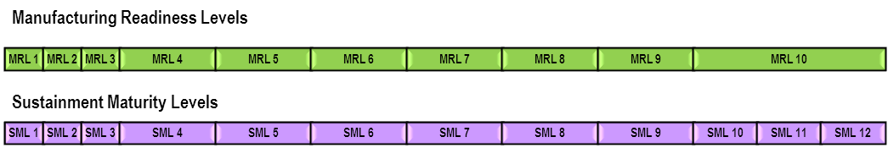
Figure 8-1 – Relationship of MRLs to SMLs
Assessments of manufacturing readiness using the MRL criteria can support the SML activities in the progression of a program where sustainment is properly addressed as a normal day-to-day activity. It is essential to understand the manufacturing maturity corresponding to the sustainment maturity and use that data to determine the risk to depot or program objectives; then implement the appropriate risk management efforts, especially for Depot Activation. Existing depot manufacturing procedures and processes need to have the same rigor of evaluation of manufacturing maturity to determine the risk to your project/program objectives.

8.3.2 Using MRL Criteria to Enhance Logistics Assessments
The DoD Logistics Assessment Guidebook states that a thorough Logistics Assessment will assist leaders in making informed decisions at milestones and/or at key program decision points. Many of the criteria in the Guidebook are directly supported by the MRL criteria. Assessing manufacturing using the MRL criteria provides better understanding of the manufacturing capability of suppliers, allowing decisions based on objective data. Minor adaptations to the language for the assessment process using MRL criteria may be required.

8.3.3 Using MRL Criteria to Enhance Depot Activities
Assessing depot manufacturing capability using the MRL criteria provides better understanding of the organic depot and depot supplier capabilities. Often, depot support decisions have to be adjusted based on “fact of life” changes. For example, support of a product was originally contracted to a business; but due to unforeseen circumstances that business is no longer available. The support activities would likely be absorbed by a military depot. This would initiate the Depot Activation process which includes major elements of the SML and MRL processes. If this product requires processes, capabilities, or components that are not within the current depot capability, then these need to be “matured.” Assessments of manufacturing (using MRL criteria) need to be performed to identify and “mature” the necessary manufacturing activities to support the product.
Figure 8.2 depicts a situation where the depot was directed to stand-up (unplanned) a capability for a product (which is Post-Milestone C/IOC). If no engineering technical data is available, the assessment of manufacturing readiness could have a target of MRL 5 (which does not support an SML 8). If limited data is available, the assessment of manufacturing readiness could have a target of MRL 6 (not supporting an SML 8). If a majority of data is available, the assessment of manufacturing readiness could have a target of MRL 7. Unless all data and processes are in place to support a product, it will take time, funding, and resources to achieve MRL 8 and support an SML 8.
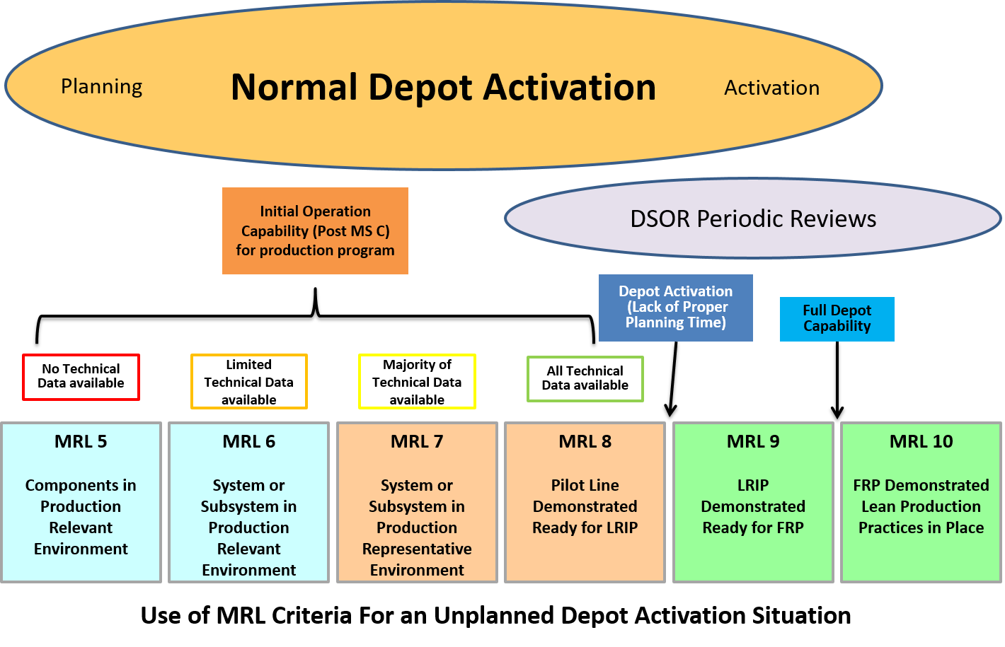
Figure 8-2 – Example of Unplanned Depot Activation Circumstance

8.3.4 Summary
In summary, assessments of manufacturing readiness using MRL criteria can support sustainment, MRO, and Depot Activation activities. A SME trained in assessment of manufacturing readiness and logistics planning is essential for product support management, logistics assessments, and depot activities. It is critical the stakeholders work together to understand what is needed to meet the MRL criteria in their application. MRL criteria must be linked to program or depot objectives to identify the risks that need to be managed. Assessments of manufacturing are essential for cost effective and reduced cycle times for sustainment and depot activities.

8.4 MRLs for Single or Limited System Acquisition
Manufacturing readiness assessments using the MRL criteria can be adapted for the acquisition of a single system or limited production systems. A single or limited production system is defined as a system in which the first unit becomes the first operational unit, e.g. a large scale radar, a class of ships, or a single or small family of satellites.

8.4.1 Single or Limited Systems – except Ships
Assessments of this type of system are accomplished by modifying the relationship of MRLs to decision points or milestones. Prior to CDR, as these systems proceed normally through the acquisition process, assessments of manufacturing readiness using the MRL criteria are performed through Milestone B as described in Section 3 (or if there is no Milestone B decision planned then through PDR).
Per DoDI 5000.02, 5.d.(10)(b):
Some programs, notably spacecraft and ships, will not produce prototypes during EMD for use solely as test articles because of the very high cost of each article. In this case, the first articles produced will be tested and then fielded as operational assets. These programs may be tailored by measures such as combining the development and initial production investment commitments. When this is the case, a combined Milestone B and C will be conducted. Additional decision points with appropriate criteria may also be established for subsequent low rate production commitments that occur prior to OT&E and a Full Rate Production Decision.
Whether traditional or tailored, a CDR that assesses design maturity, design build-to or code-to documentation, and remaining risks and establishes the initial product baseline, is required. Manufacturing maturity at CDR must be sufficient to support a First Build decision point with acceptable risk. First Build approval and First System Build normally occur shortly after successful CDR completion (see Figure 8.3). Although the build occurs during EMD, this is also the first (and possibly only) production system. As such, to achieve an acceptable level of risk, the system level manufacturing maturity must meet MRL 8 criteria at the CDR decision point, and the sub-system and component levels maturity must meet MRL 8 or 9 criteria. As a waypoint in mid-development between PDR and CDR, an assessment against the MRL 7 criteria may be performed to meet program objectives.
In addition, for space systems, where hardware replacement or repair is not possible and quality and reliability are of paramount importance, the initial units (i.e., EMD units for satellites) are required to meet all mission operational requirements. This dictates complete documentation and traceability of all flight units (the “as-built” documentation), which is key in support of on-orbit anomaly analysis. Quality and reliability must be emphasized when conducting manufacturing readiness assessments of space vehicles.
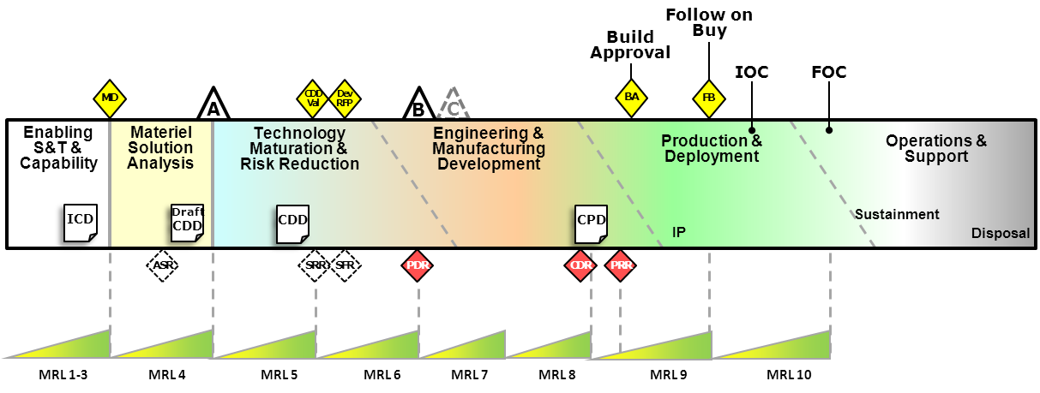
Figure 8-3 – Single or Limited System Acquisitions – except Ships
Relationship of MRLs to Decision Points
Certain criteria and language in the MRL threads and sub-threads may require adhering to a more stringent definition to meet the requirements for single or limited system acquisitions. For example, in the Materials Maturity sub-thread (D.1), MRL 7, “Material Maturity sufficient for pilot line build,” sufficient means fully characterized. For MRL 8, “Materials proven and validated during EMD as adequate to support LRIP,” as LRIP is the initial production EMD system, adequate means fully proven and validated. The strict adherence to a high-level definition reduces risk for successful production of single or limited systems where manufacturing risk control is a primary concern.
Another example, in the Manufacturing Process Maturity sub-thread (E.2), demonstrating and verifying manufacturing processes can be difficult, as can collection and calculation of process capability when producing a single system. Existing proven and capable manufacturing procedures and processes should be utilized for production process verification as much as possible and equipment utilized must meet capability requirements.

8.4.2 Single or Limited Systems – Ships
In the case of ship acquisition, a complex Systems of Systems, the major systems and subsystems should be fully characterized, if not in production (i.e., MRL 8 or 9) before ship CDR. At the overall ship development level, as Milestone B typically takes place three to six months after CDR, the overall ship design should be at MRL 7 by Milestone B.
Multiple shipyards may be working independently to prepare functional designs in accordance with their particular shipyard’s production methodology and processes, moving their designs towards MRL 8.
In order to improve governance and insight, ensure alignment between capability requirements and acquisition, improve senior leadership decision making, and gain better understanding of risks and costs, the Department of the Navy has implemented a “2-pass, 6-gate” process. Gates 1, 2, and 3 are “requirement gates”, starting prior to Materiel Development Decision which lead to approval of the ICD, the AoA guidance, section of an AoA “optimal” alternative, approval of a CDD, development of a CONOPS, and approval of a System Design Specification (SDS) Development Plan. At System Design (SD) 1 Final Design Review (equivalent to PDR) the system maturity should be at MRL 6. Gates 4, 5, and 6, the “acquisition” gates, start after Gate 3, end after Milestone B (initial EMD phase). This process results in approval of the SDS, releasing of the RFP, assessing readiness for production, and approval of the Initial Baseline Review. Post Gate 4 (and potentially Gate 5) with the SD2 completion (equivalent to CDR) at Milestone B, the system maturity should be at MRL 7.
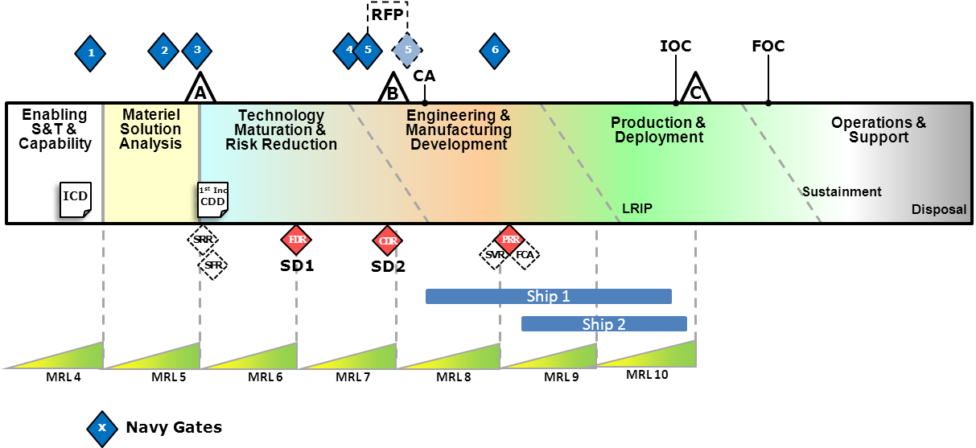
Figure 8-4 – Single or Limited System Acquisitions – Ships
Relationship of MRLs to Decision Points
Once MS B has taken place, the ship’s detailed design and construction begins. With Contract Award (CA), the winning shipyard continues with the design and construction in preparation for PRR at MRL 8. A year or more may elapse between CA and PRR, with PRR required before the LRIP/lead ship construction start decision (laying the keel) and follow-on ships.
For ships at CDR all major ship sub-systems (propulsion, weapon systems, combat systems, etc.) required for the platform to function as a ship should be at MRL 8. Also, any sub-system in this systems-of-systems that is not possible to replace or retrofit must be at MRL 8. To reach this level of maturity, modeling and simulations, including potentially building full scale subsystems (not part of the ship systems) may be used.

8.4.3 Summary
In summary, assessments of manufacturing readiness based on MRL criteria can encompass single or limited system acquisitions with adaptions to the assessment process and maturity required at decision points or milestones.

8.5 MRL Criteria for Industry
Industry can leverage and adapt the DoD MRL criteria to their company processes. The criteria translate easily across both military and commercial application.
A simple step to adapt the tool begins with embedding business vernacular into the criteria that improve the understanding and acceptance of the assessment process. For example, using company vocabulary instead of the DoD terms (e.g., business or engineering Gates instead of Milestones) as depicted in Figure 8.5.
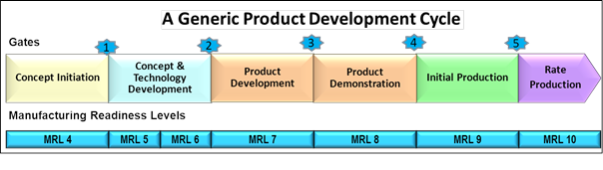
Figure 8-5 – Gated Product Development
To aid in building the manufacturing maturation plan, a company may create a roadmap to follow into the future, emphasizing value added processes instead of identifying what actions were not completed.
A company can embed the complete MRL criteria and assessment process into one spreadsheet or management dashboard. As results are presented and team buy-in increases, improvements are seen by increased productivity. Standardized report out presentation or standardized dashboard formats across the business aids in better upper level management buy-in. When a business assumes ownership of the MRL criteria, it can be concise and controllable, allowing for quick resolution of interpretation problems. Ownership also allows lessons learned to be added to the MRL criteria. For example, including an Environmental, Safety, and Health (ESH) thread, insures that ESH issues are addressed early in the maturation process.
Manufacturing assessments using MRL criteria should be adapted as an integral required element of a company’s new product introduction process. Similar to implementation of ISO 9000/9001 and AS6500, implementation of manufacturing assessments using the MRL criteria to manage risk will improve company operations, leading to improved quality, reduced cycle times, reduced costs, and positive overall impact.

APPENDIX A – Detailed MRL Criteria

Table A-1. Manufacturing Readiness Levels for the Technology and Industrial Base Thread
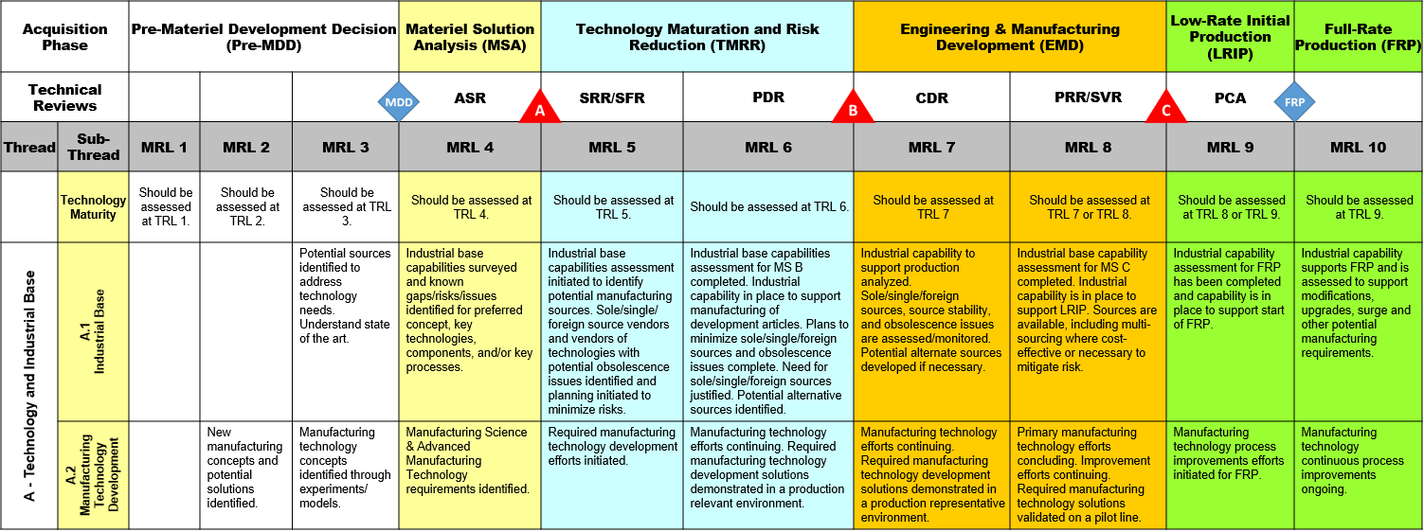

Table A-2. Manufacturing Readiness Levels for the Design Thread
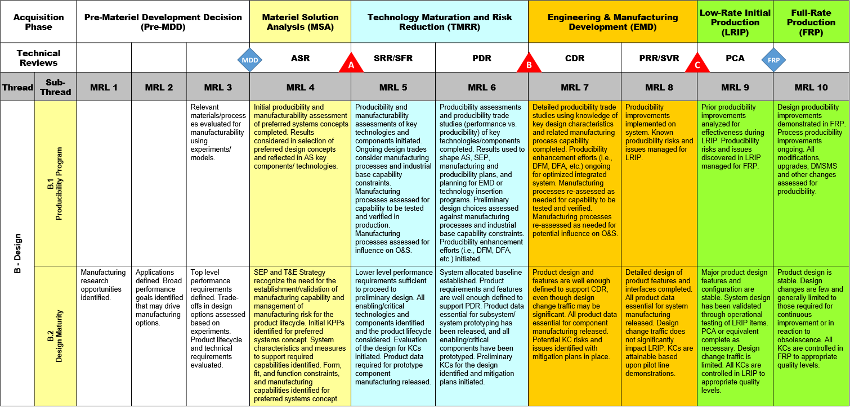

Table A-3. Manufacturing Readiness Levels for the Cost and Funding Thread
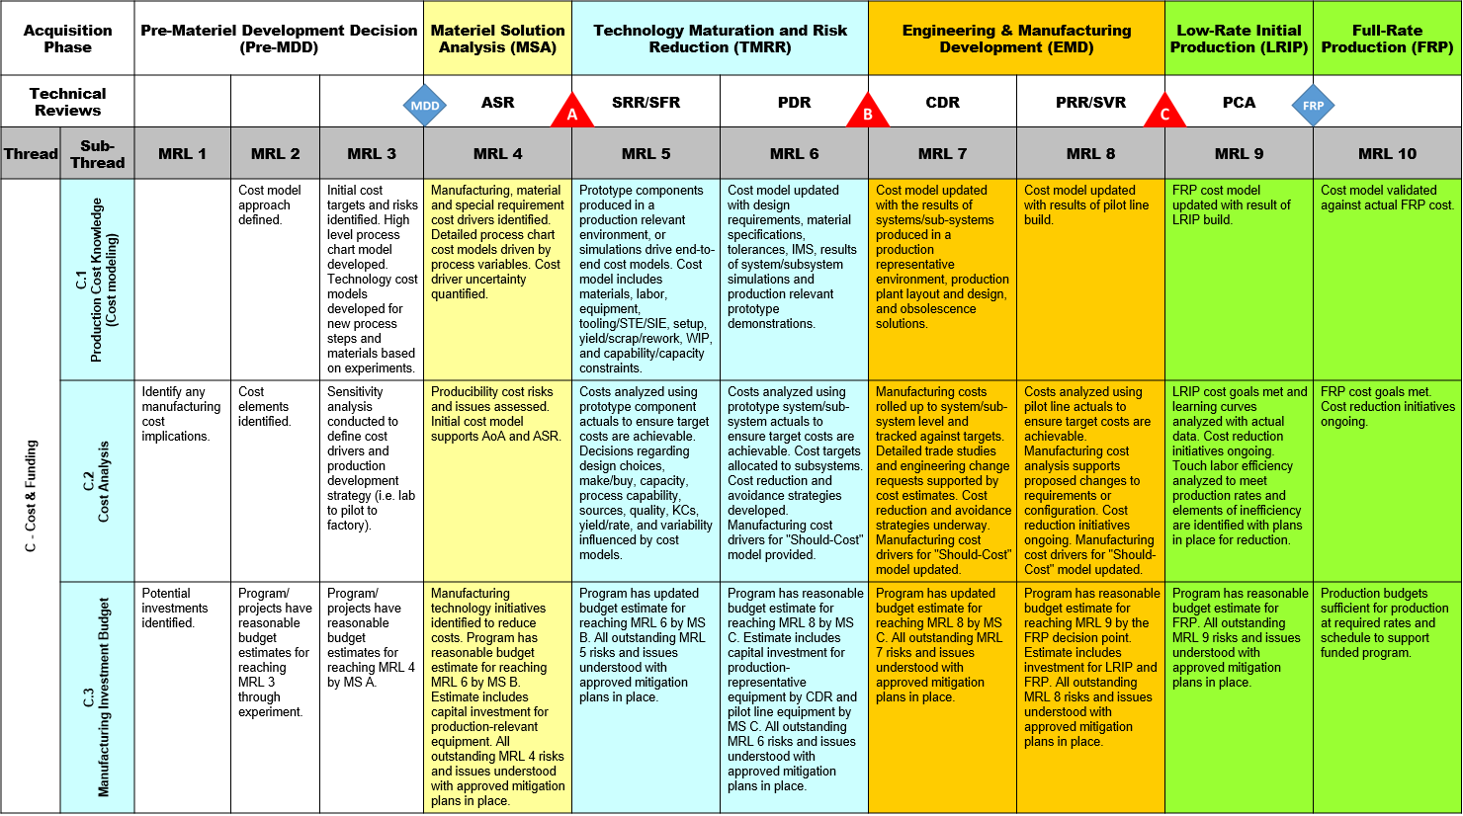

Table A-4. Manufacturing Readiness Levels for the Materials Thread
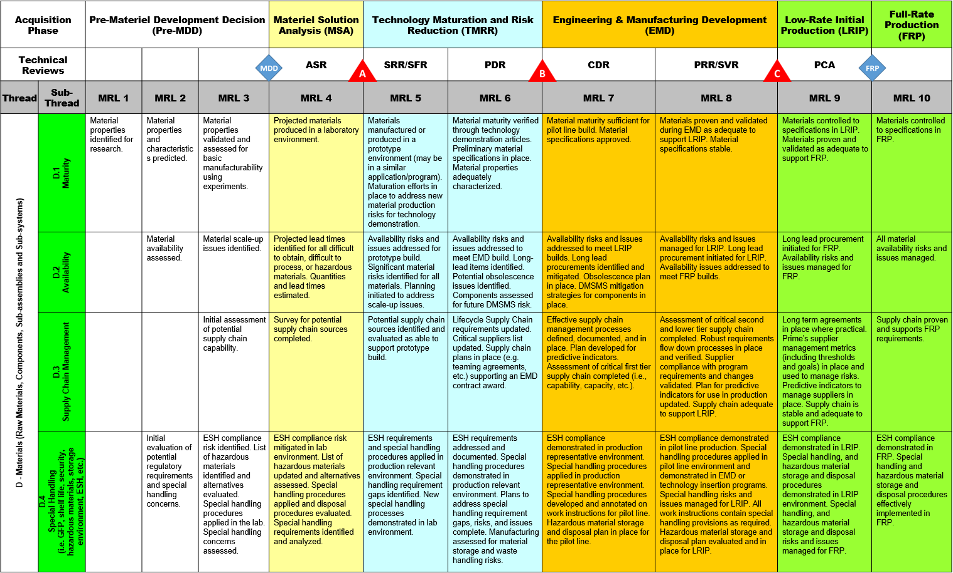

Table A-5. Manufacturing Readiness Levels for the Process Capability and Control Thread
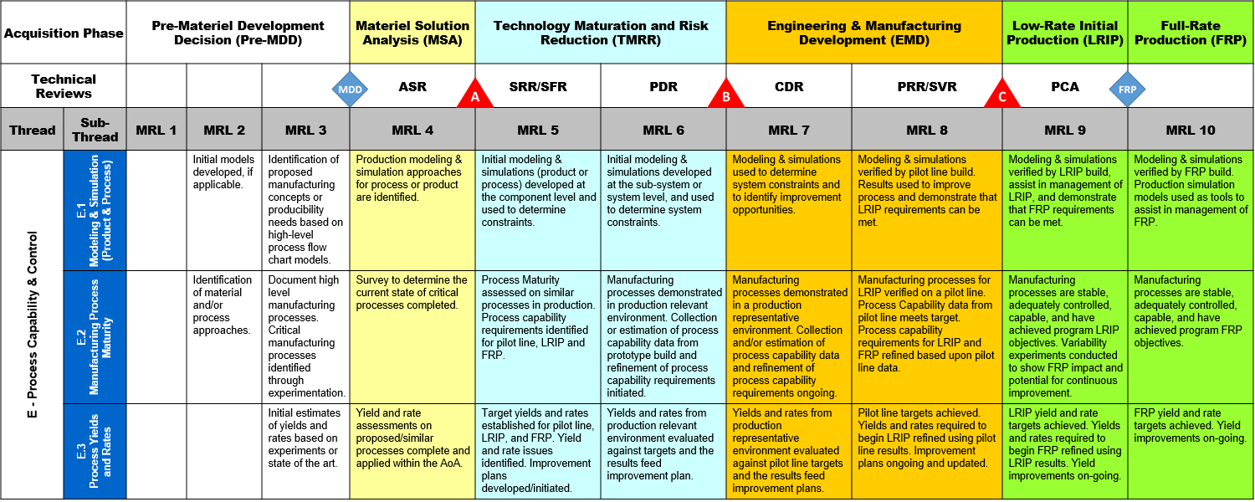

Table A-6 Manufacturing Readiness Levels for the Quality Management Thread
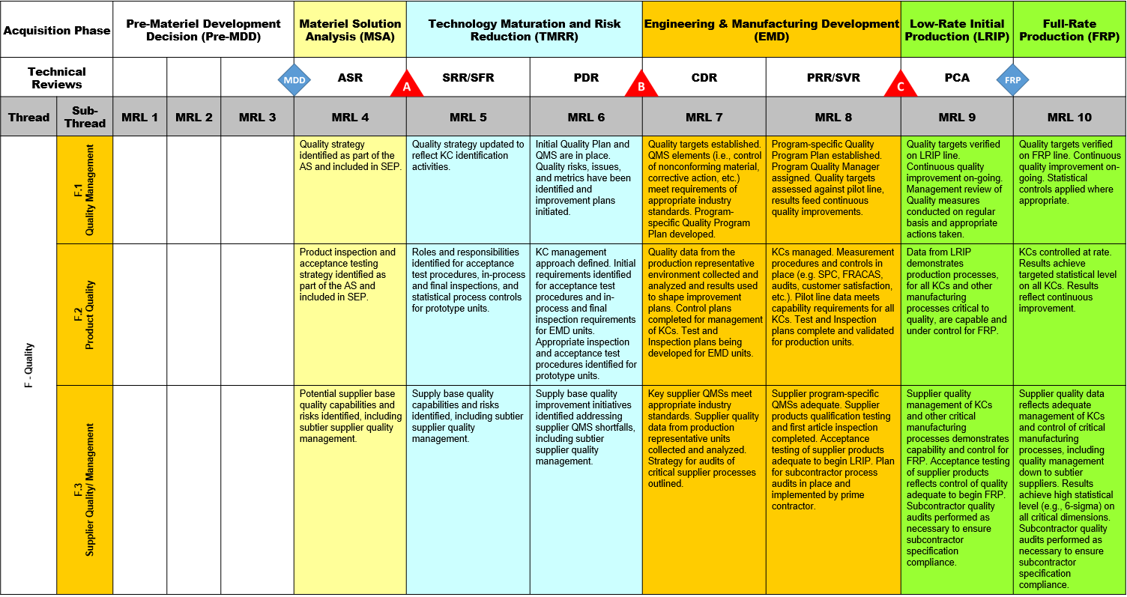

Table A-7. Manufacturing Readiness Levels for the Manufacturing Personnel and Facilities Threads
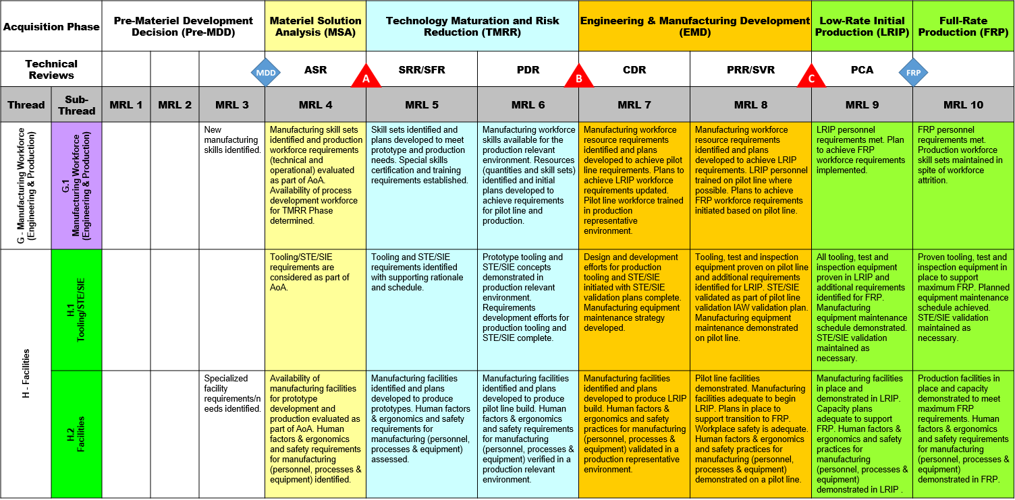

Table A-8. Manufacturing Readiness Levels for the Manufacturing Management Thread

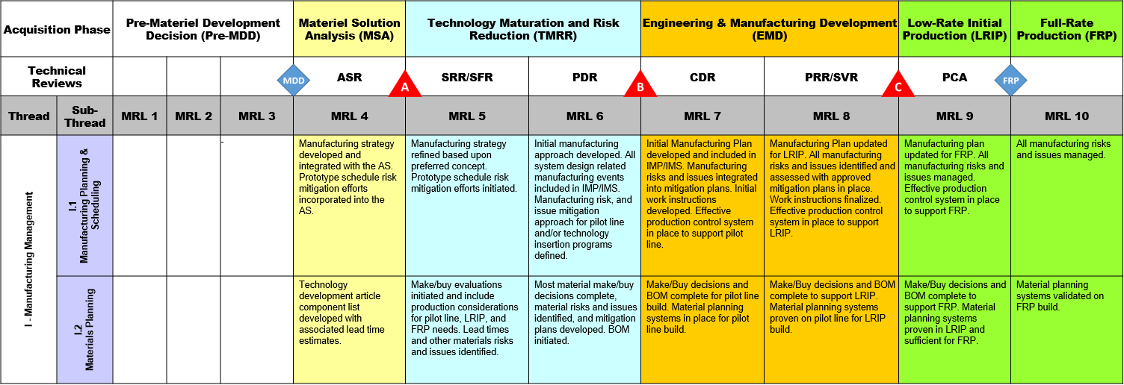

APPENDIX B – Acronyms
ACTD Advanced Concept Technology Demonstration
AoA Analysis of Alternatives
AS Acquisition Strategy
ASR Alternative System Review
ATD Advanced Technology Demonstration
BOM Bill of Materials
CA Contract Award
CDD Capability Development Document
CDR Critical Design Review
CDRL Contract Data Requirements List
CONOPS Concept of Operations
CPD Capability Production Document
DAB Defense Acquisition Board
DAG Defense Acquisition Guidebook
DCMA Defense Contract Management Agency
DFA Design for Assembly
DFARS Defense Federal Acquisition Regulation Supplement
DFM Design for Manufacturing
DID Data Item Description
DoDI Department of Defense Instruction
DMSMS Diminishing Manufacturing Sources and Material Shortages
ESH Environmental, Safety, and Health
EMD Engineering and Manufacturing Development

FRACAS Failure, Reporting, Analysis, and Corrective Action System
FRP Full Rate Production
FOC Full Operational Capability
GAO Government Accountability Office
GFP Government Furnished Property
IAW In accordance with
ICA Industrial Capabilities Assessment
ICD Initial Capabilities Document
IMP Integrated Master Plan
IMS Integrated Master Schedule
IOC Initial Operational Capability
ITR Initial Technical Review
JDMTP Joint Defense Manufacturing Technology Panel
KC Key Characteristic
KPP Key Performance Parameter
LRIP Low Rate Initial Production
MDA Milestone Decision Authority
MDD Materiel Development Decision
MMP Manufacturing Maturation Plan
MRL Manufacturing Readiness Level
MS A Milestone A (DoD decision point)
MS B Milestone B (DoD decision point)
MS C Milestone C (DoD decision point)
MSA Materiel Solution Analysis
NASA National Aeronautics and Space Agency
O&S Operations and Support (DoD acquisition phase)
OEM Original Equipment Manufacturer
PCA Physical Configuration Audit
PDR Preliminary Design Review
Pre-MDD Pre-Materiel Development Decision (DoD acquisition phase)
PRR Production Readiness Review

PSM Product Support Manager Guidebook
PWB Printed Wiring Board
QMS Quality Management System
RFP Request for Proposals
S&T Science & Technology
SD System Design
SDS System Design Specification
SEP Systems Engineering Plan
SIE Special Inspection Equipment
SFR System Functional Review
SME Subject Matter Expert
SML Sustainment Maturity Level
SOO Statement of Objectives
SOW Statement of Work
SPC Statistical Process Control
SRR System Requirement Review
STE Special Test Equipment
SVR System Verification Review
T&E Test and Evaluation
TBD To Be Determined
TMRR Technology Maturation Risk Reduction
TRA Technology Readiness Assessment
TRL Technology Readiness Level
TRR Test Readiness Review
WIP Work in Process

Manufacturing risk is one element of overall technical risk to the program.
Defense Acquisitions: Assessment of Selected Weapon Programs, Government Accountability Office (GAO -09-326SP), March 30, 2009. Similar conclusions were made in prior GAO reports issued annually around the same time of the year. These reports may be accessed at http://www.gao.gov/docsearch/agency.php.
Sub-Part 207.1, ”Acquisition Plans,” Defense Federal Acquisition Regulation Supplement (DFARS), revised July 29, 2009; http://www.acq.osd.mil/dpap/dars/dfarspgi/current/index.html.
P.L. 112-81, 31 Dec 2011: § 834
P.L. 114-328, 23 Dec 2016: § 807
GAO 10-439, Apr 2010
Page 84, DoDI 5000.02, January 7, 2015
Page 19, DoDI 5000.02, January 7, 2015
Page 24, DoDI 5000.02, January 7, 2015
Page 84, DoDI 5000.02, January 7, 2015
Page 23, DoDI 5000.02, January 7, 2015
Chapter 4, Systems Engineering; Defense Acquisition Guidebook, Defense Acquisition University, June 28, 20139; https://dag.dau.mil/Pages/Default.aspx
These technology development/demonstration projects include all basic and applied research, science and technology, component development, and prototype efforts that are transitioning into an acquisition program.
The acquisition life cycle is defined by the acquisition management system.
The term “program” refers to an acquisition program of record. The term “project” refers to any technology development effort (ranging from basic research to advanced component development and prototypes) prior to the establishment of a program of record in the acquisition life cycle even though an acquisition program office is often formed prior to that point in time.
The MMP addresses the manufacturing risk and provides a mitigation plan for each risk area. See section 5 of this Deskbook.
An acquisition program that has been formally initiated by the Milestone Decision Authority and has been fully funded throughout the Future Years Defense Plan.
Section 3 of this Deskbook provided guidelines for expectations at key decision points in the acquisition management system.

